European air quality report 2014

Figures, Tables and Maps

Version for Eionet review 16 July 2014

Table ES.1 Percentage of the urban population in the EU28 exposed to air pollutant concentrations above the EU and WHO reference levels (2010-2012)

Pollutant
EU reference value
Exposure estimate (%)
WHO AQG
Exposure estimate (%)
PM
2
.
5
year
(
25
)
10
–
14
year
(
10
)
94
–
96
PM
10
day
(
50
)
21
–
30
year
(
20
)
69
–
89
O
3
8
-
hour
(
120
)
14
–
17
8
-
hour
(
100
)
97
–
99
NO
2
year
(
40
)
8
–
13
year
(
40
)
8
–
13
BaP
year
(
1
ng/m
3
)
24
–
28
year (0.12 ng/m
3
)
77
–
88
SO
2
day
(
125
)
< 1
day
(
20
)
37
–
42
CO
8
-
hour
(
10
)
< 2

8
-
hour
(
10
)
< 2

Pb
year
(
0
.
5
)
< 1

year
(
0
.
5
)
< 1

Benzene
year
(
5
)
< 1
year
(
1
.
7
)
10
–
12
Colour
coding
:
<
5
%
5
-
50
%
50
-
75
%
>
75
%
Note: The pollutants are ordered in terms of their relative risk for health damage — highest on top.
The estimated range in exposures refers to a recent three year period (2010-2012) and includes variations due to meteorology, as dispersion and atmospheric conditions differ from year to year.
The reference levels included EU limit or target levels and WHO air quality guidelines (AQG).
The reference levels in brackets are in μg/m³ except for CO which is in mg/m³ and BaP in ng/m³.
For some pollutants EU legislation allows a limited number of exceedances. This aspect is considered in the compilation of exposure in relation to EU air quality limit and target values.
The comparison is made for the most stringent EU limit or target values set for the protection of human health. For PM10 the most stringent standard is for 24-hour mean concentration.
As the WHO has not set AQG for BaP and benzene the WHO reference level in the table was estimated assuming an additional lifetime risk of 1 x 10⁻⁵.
Sources: EEA, 2014a (CSI 004); AirBase v. 8

Figure ES.1 Development of population weighted concentrations in urban agglomerations in EU28 for PM10, O₃, and NO₂, 1997 to 2012.

Sources: EEA/Eurostat, Structural Indicator

Figure 1.1 Impacts of air pollution

Source: EEA

Table 2.1 Legislation in Europe regulating emissions and ambient concentrations of air pollutants
 | Pollutants  Policies | PM | O₃ | NO₂  NO_{X}  NH₃ | SO₂  SO_{X} | CO | Heavy metals | BaP  PAH | VOCs
Directives regulating ambient air quality | 2008/50/EC | PM | O₃ | NO₂ | SO₂ | CO | Pb |  | Benzene
Directives regulating ambient air quality | 2004/107/EC |  |  |  |  |  | As, Cd, Hg, Ni | BaP
Directives regulating emissions of air pollutants | 2001/81/EC | (ª) | (^{b}) | NO_{X}, NH₃ | SO₂ |  |  |  | NMVOC
Directives regulating emissions of air pollutants | 2010/75/EU | PM | (^{b}) | NO_{X}, NH₃ | SO₂ | CO | Cd, Tl, Hg, Sb, As, Pb, Cr, Co, Cu, Mn, Ni, V |  | VOC
Directives regulating emissions of air pollutants | Euro standards on road vehicle emissions | PM | (^{b}) | NO_{X} |  | CO |  |  | VOC, NMVOC
Directives regulating emissions of air pollutants | 94/63/EC | (ª) | (^{b}) |  |  |  |  |  | VOC
Directives regulating emissions of air pollutants | 2009/126/EC | (ª) | (^{b}) |  |  |  |  |  | VOC
Directives regulating emissions of air pollutants | 1999/13/EC | (ª) | (^{b}) |  |  |  |  |  | VOC
Directives regulating emissions of air pollutants | 91/676/EEC |  |  | NH₃
Directives regulating fuel quality | 1999/32/EC | (ª) |  |  | S
Directives regulating fuel quality | 2003/17/EC | (ª) | (^{b}) |  | S |  | Pb | PAH | Benzene, VOCs
International conventions | MARPOL 73/78 | PM | (^{b}) | NO_{X} | SO_{X} |  |  |  | VOC
International conventions | LRTAP | PM  (ª) | (^{b}) | NO₂, NH₃ | SO₂ | CO | Cd, Hg, Pb | BaP | NMVOC

(ª) Directives and conventions limiting emissions of particulate matter precursors, such as SO₂, NO_{X}, NH₃ and VOCs, indirectly aim to reduce particulate matter ambient air concentrations.
(^{b}) Directives and conventions limiting emissions of ozone precursors, such as NO_{X}, VOC and CO, indirectly aim to reduce troposphere ozone concentrations.

Figure 3.1 Development in EU28 emissions of PM2.5, PM10, NO_{x}, SO_{x}, NH₃, NMVOC, CO and CH₄ (top) and of As, Cd, Ni, Pb, Hg, and BaP (bottom) from 2003 to 2012.

Note: CH₄ emissions are total emissions (IPPC sectors 1-7) excluding sector 5. LULUCF (land use, land use change and forestry).

Source: EEA.

Figure 3.2 Contributions to EU28 emissions from main source sectors (Gg/year=1000 tonnes/year) of PM10, PM2.5, NO_{X}, SO_{X}, NMVOCs and CO, 2003–2012.

Source: EEA.
Figure 3.3 Contributions to EU28 emissions from main source sectors (Gg/year=1000 tonnes/year) of BaP, Pb, Cd, As, Ni and Hg, 2003–2012.

Source: EEA.

Figure 4.1 Health effects pyramid

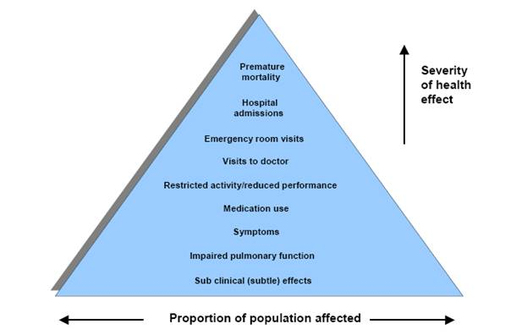
Source: Based on US EPA

Table 4.1 Effects of air pollutants on human health
Pollutant | Health effects
Particulate matter (PM) | Can cause or aggravate cardiovascular and lung diseases, heart attacks and arrhythmias, affect the central nervous system, the reproductive system and cause cancer. The outcome can be premature death.
Ozone (O₃) | Can decrease lung function; aggravate asthma and other lung diseases. Can lead to premature mortality.
Nitrogen oxides (NO₂) | NO₂ can affect the liver, lung, spleen and blood. Can aggravate lung diseases leading to respiratory symptoms and increased susceptibility to respiratory infection.
PAHs, in particular Benzo-a-pyrene (BaP) | Carcinogenic. Other effects may be irritation of the eyes, nose, throat and bronchial tubes.
Sulphur oxides (SO_{X}) | Aggravates asthma and can reduce lung function and inflame the respiratory tract. Can cause headache, general discomfort and anxiety.
Carbon monoxide (CO) | Can lead to heart disease and damage to the nervous system; can also cause headache, dizziness and fatigue.
Arsenic | Inorganic arsenic is a human carcinogen. It can lead to damage in the blood, heart, liver and kidney. May also damage the peripheral nervous system.
Cadmium | Cadmium, especially cadmium oxide, is likely to be a carcinogen. It may cause damage to the reproductive and respiratory systems.
Lead | Can affect almost every organ and system, especially the nervous system. Can cause premature birth, impaired mental development and reduced growth.
Mercury | Can damage the liver, the kidneys and the digestive and respiratory systems. It can also cause brain and neurological damage and impair growth.
Nickel | Several nickel compounds are classified as human carcinogens. It may cause allergic skin reactions, as well as affecting the respiratory, immune and defence systems.
Benzene | A human carcinogen, which can cause leukaemia and birth defects. Can affect the central nervous system and normal blood production, and can harm the immune system.
Table 4.2 Summary of the Air Quality Directives limit values, target values, long-term objectives, information and alert threshold values for the protection of human health

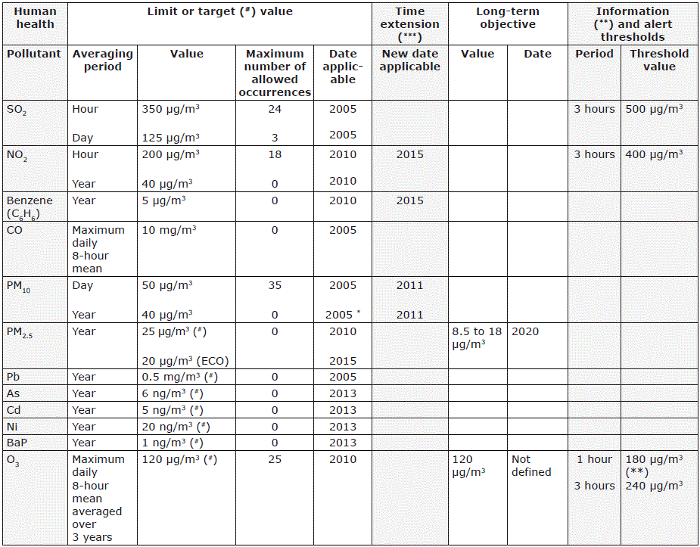
Note: ECO: The exposure concentration obligation for PM2.5, to be attained by 2015, is fixed on the basis of the average exposure indicator (see main text), with the aim of reducing harmful effects on human health. The range for the long-term objective (between 8.5 and 18) indicates that the value is depending on the initial concentrations in the various Member States.
(#) Signifies that this is a target value and not a legally binding limit value; see EU, 2008c for definition of legal terms (Article 2). (*) Exceptions are Bulgaria and Romania, where the date applicable was 2007. (**) Signifies that this is an information threshold and not an alert threshold; see EU, 2008c for definition of legal terms (Article 2). (***) For countries that sought and qualified for time extension.
Source: EU, 2004, 2008c

Table 4.3 WHO air quality guidelines (AGL), interim targets (IT) and reference levels (RL) for PM, O₃, NO₂, BaP, SO₂, CO, and toxic metals. Units in µg/m³, except for BaP, CO, cadmium and lead.
 |  |  | IT-1 | IT-2 | IT-3 | AQG |  | RL**
PM10 | 24 h* |  | 150 | 100 | 75 | 50
 | annual |  | 70 | 50 | 30 | 20
PM2.5 | 24 h* |  | 75 | 50 | 37.5 | 25
 | annual |  | 35 | 25 | 15 | 10
O3 | 8 h daily max |  |  |  |  | 100
NO2 | 1 h |  |  |  |  | 200
 | annual |  |  |  |  | 40
BaP | annual |  |  |  |  |  |  | 0.12 ng/m³
SO2 | 10 minutes |  |  |  |  | 500
 | 24 h |  |  |  |  | 20
CO | 1 h |  |  |  |  | 30 mg/m³
 | 8 h |  |  |  |  | 10 mg/m³
Arsenic | annual
Cadmium | annual |  |  |  |  | 5 ng/m³***
Nickel | annual
Lead | annual |  |  |  |  | 500 ng/m³
Benzene | annual |  |  |  |  |  |  | 1.7

Notes: * 99th percentile (3 days/year)
** As the WHO has not set an AQG for BaP and benzene, the WHO reference level was estimated
assuming an additional lifetime risk of 1 x 10⁻⁵.
*** AQG set to prevent any further increase of cadmium in agricultural soil, likely to increase the dietary
intake of future generations.
Sources: WHO, 2000; WHO, 2006a

Map 4.1 Concentrations of PM₁₀ in 2012
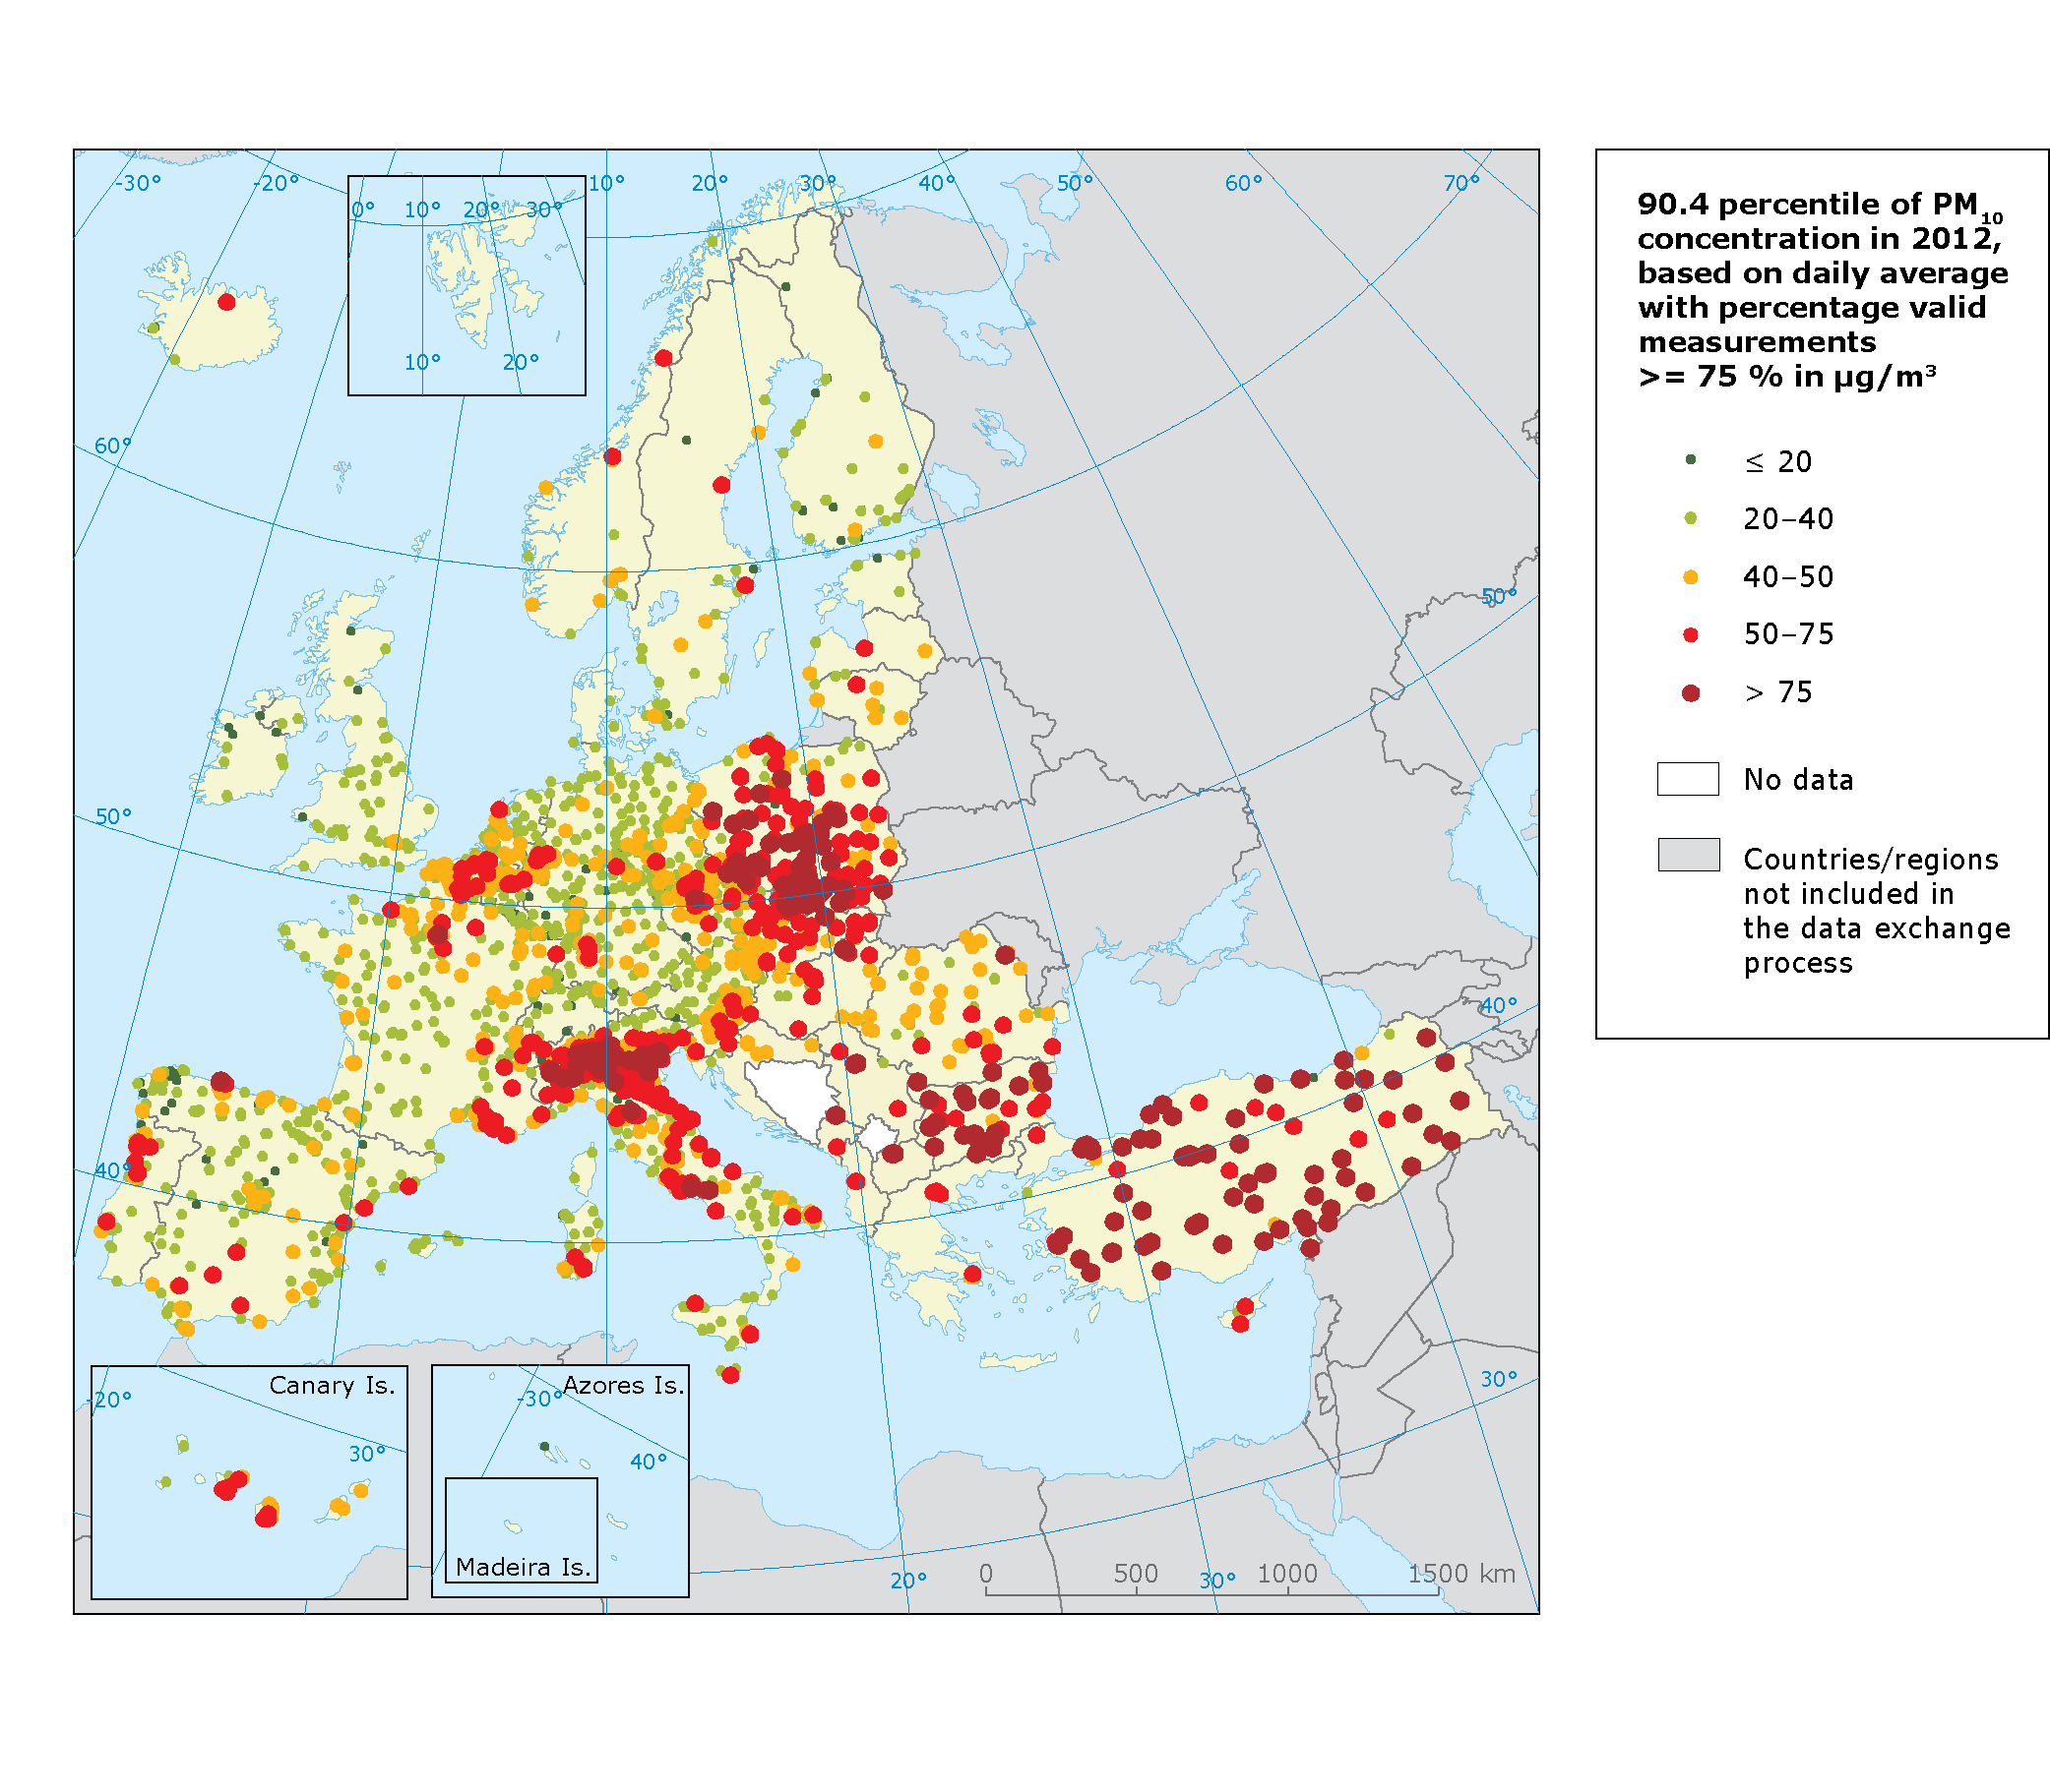
Note:
The map shows the proximity of recorded PM10 concentrations to the daily limit value, allowing 35 exceedances over one year of the 50 μg/m3 threshold – represented here by the 90.4 percentile of the data records in one year. Exceedances are shown as red and dark red dots.
Source: Airbase v. 8

Map 4.2 Concentrations of PM_{2.5} in 2012
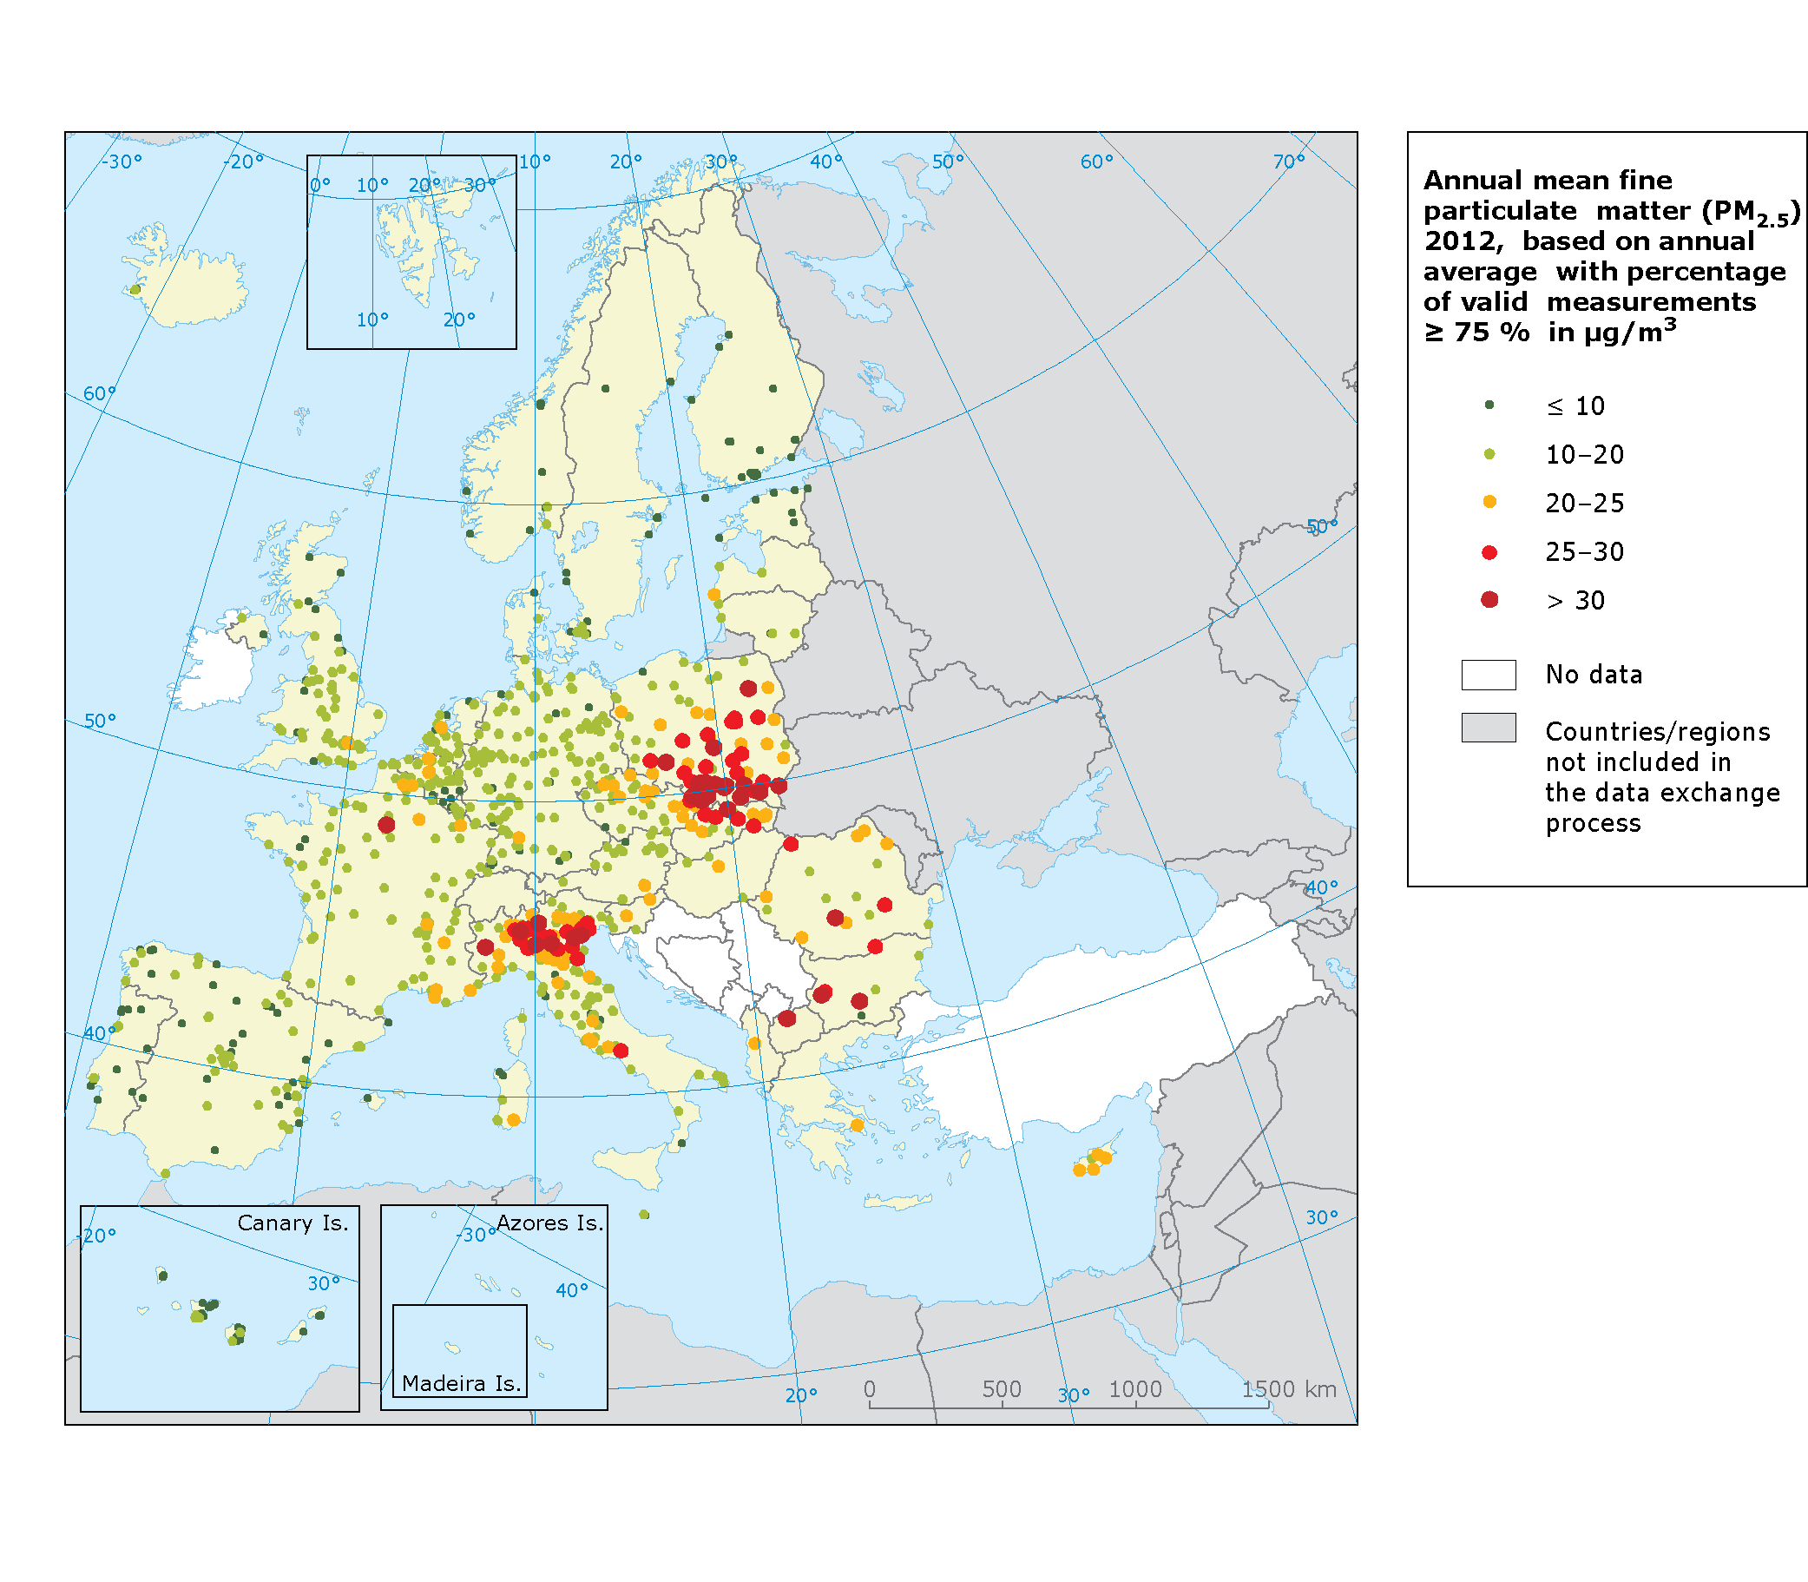

Note:
The dark red dots indicate stations reporting exceedances of the 2010 annual target value (25 μg/m³) plus at least 5 μg/m³.
The red dots indicate stations reporting exceedances of the 2010 annual target value (25 μg/m³), as set out in the Air Quality Directive (EU, 2008c).
The orange dots indicate stations reporting exceedances of the 2020 indicative annual limit value (20 μg/m³), as set out in the Air Quality Directive (EU, 2008c).
The pale green dots indicate stations reporting exceedances of the WHO air quality guideline for PM_{2.5} of less than 10 μg /m³.
The dark green dots indicate stations reporting concentrations below the WHO air quality guideline for PM_{2.5}.
Source: Airbase v.8

Map 4.3 Concentrations of O₃ in 2012
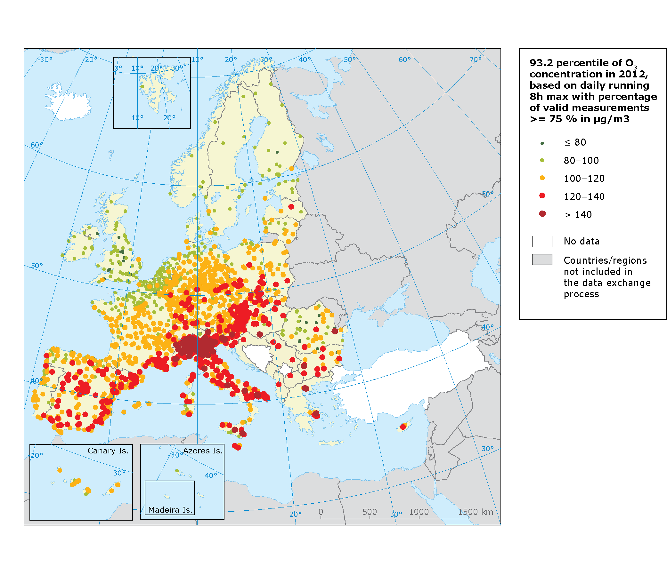

Note: The map shows the proximity of recorded O₃ concentrations to the target value, allowing 25 exceedances of the 120 μg/m³ threshold – represented here by the 93.2 percentile of the data records in one year. Exceedances are shown as red and dark red dots.

Source: Airbase v. 8

Map 4.4 Concentrations of NO₂ in 2012
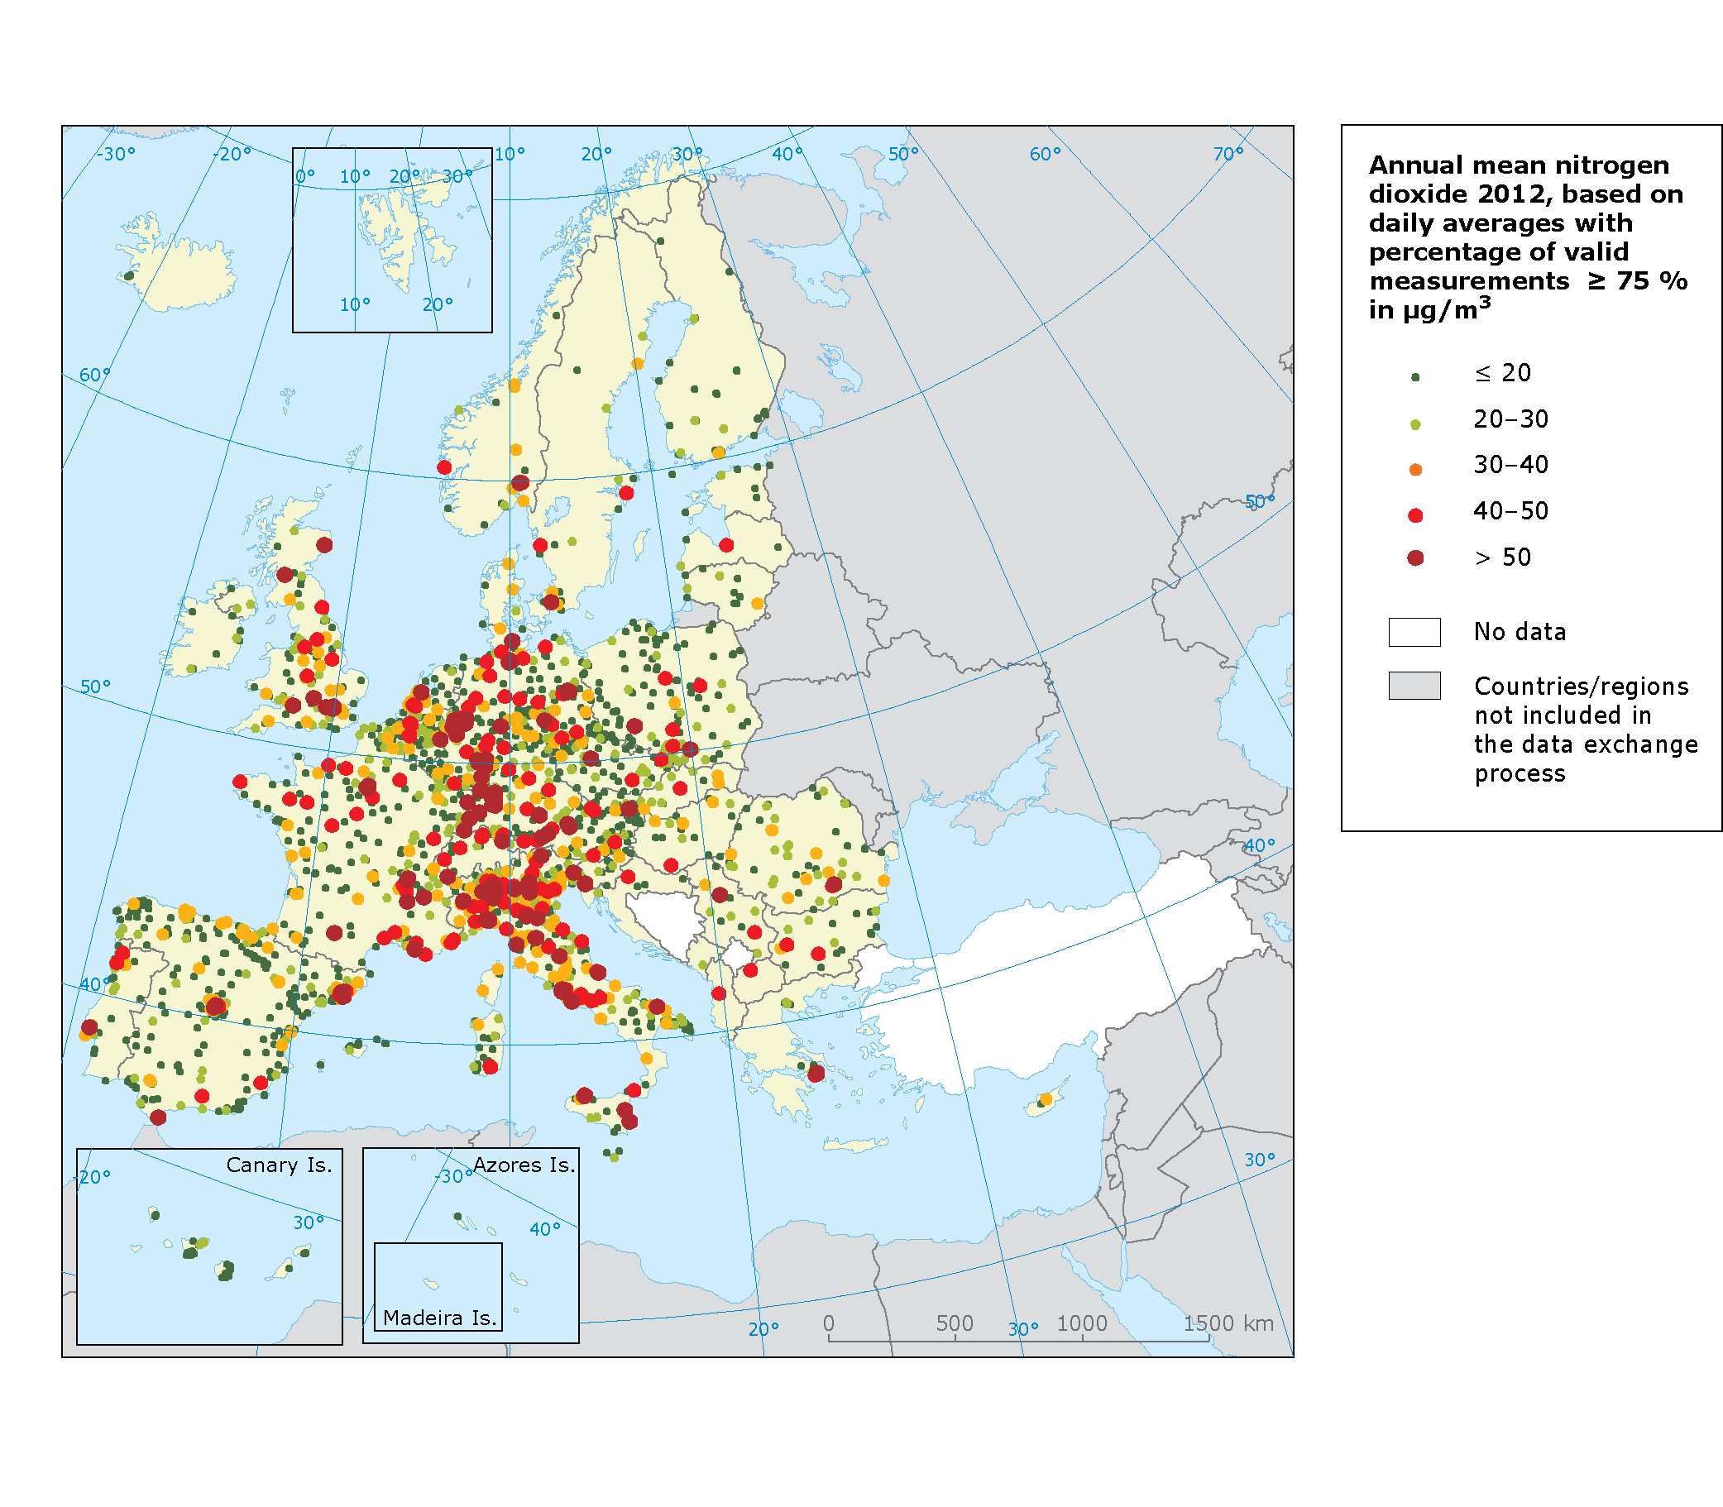

Note: Red and dark red dots correspond to exceedances of the annual limit value (40 μg/m³).
Dark red dots correspond to exceedances of the annual limit value + 10μg/m³.
Source: AirBase v. 8

Map 4.5 Concentrations of benzo(a)pyrene in 2012
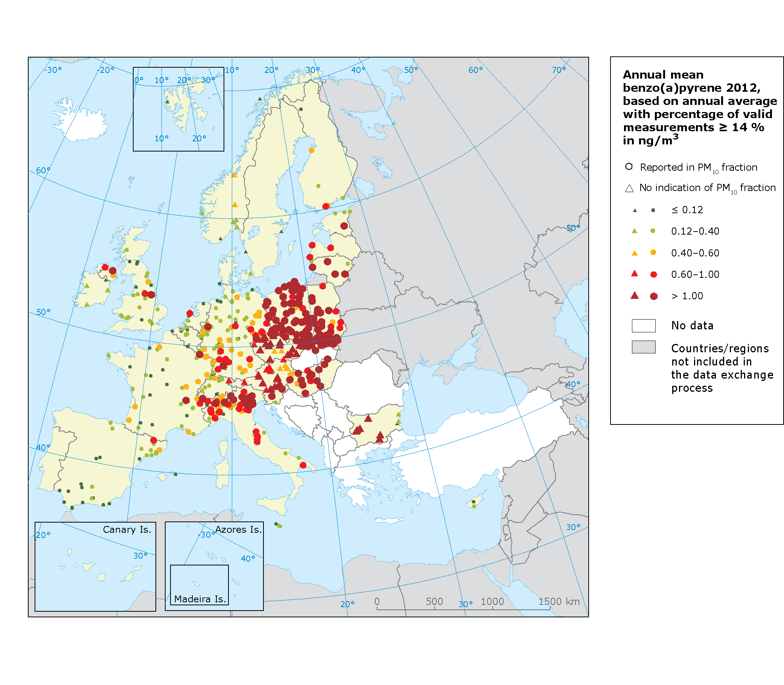
Note: Dark green dots correspond to concentrations under the WHO reference level (0.12 ng/m³).
Pale green dots correspond to concentrations under the lower assessment threshold (0.4 ng/m³).
Orange dots correspond to concentrations under the upper assessment threshold (0.6 ng/m³).
Red dots correspond to concentrations under the target value of 1 ng/m³.
Dark red dots correspond to concentrations exceeding the target value of 1 ng/m³.

Source: AirBase v. 8

Map 4.6 Concentrations of carbon monoxide in 2012

Map 4.7 Concentrations of arsenic, cadmium, lead and nickel in 2012
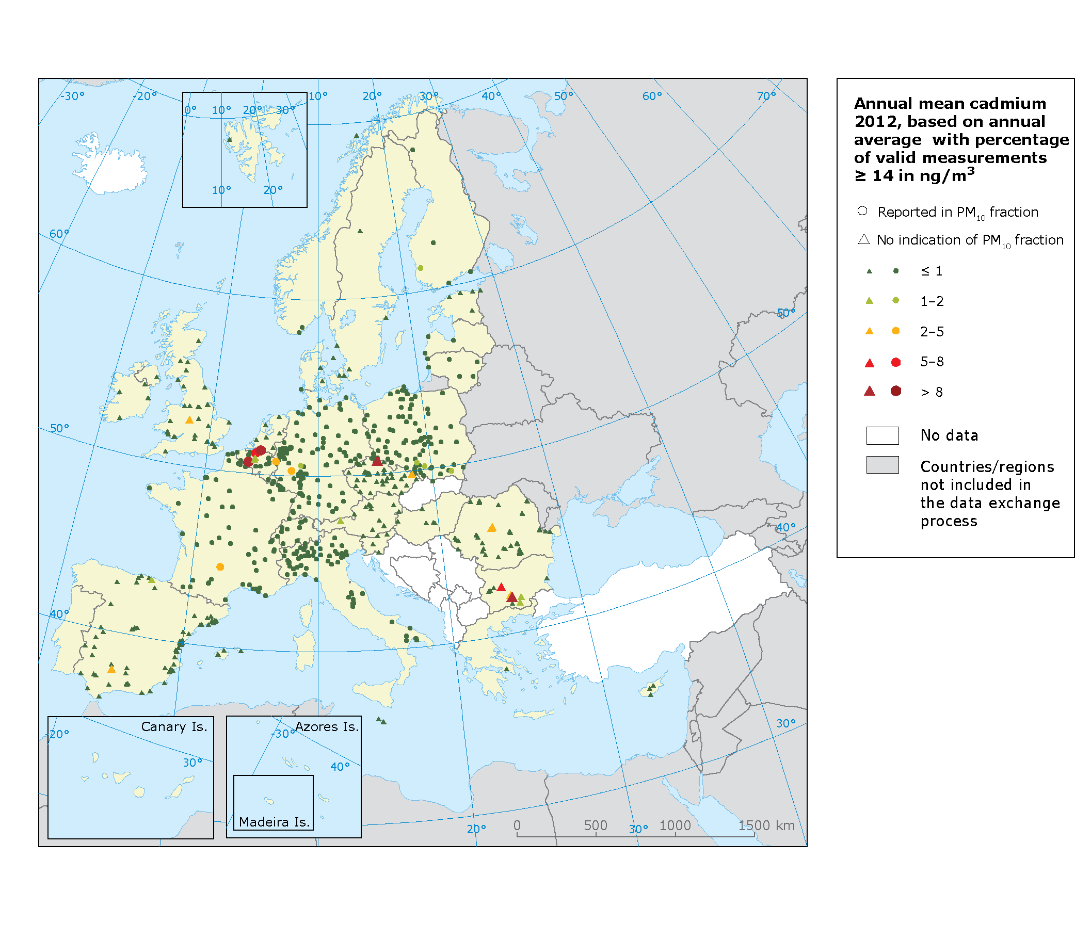

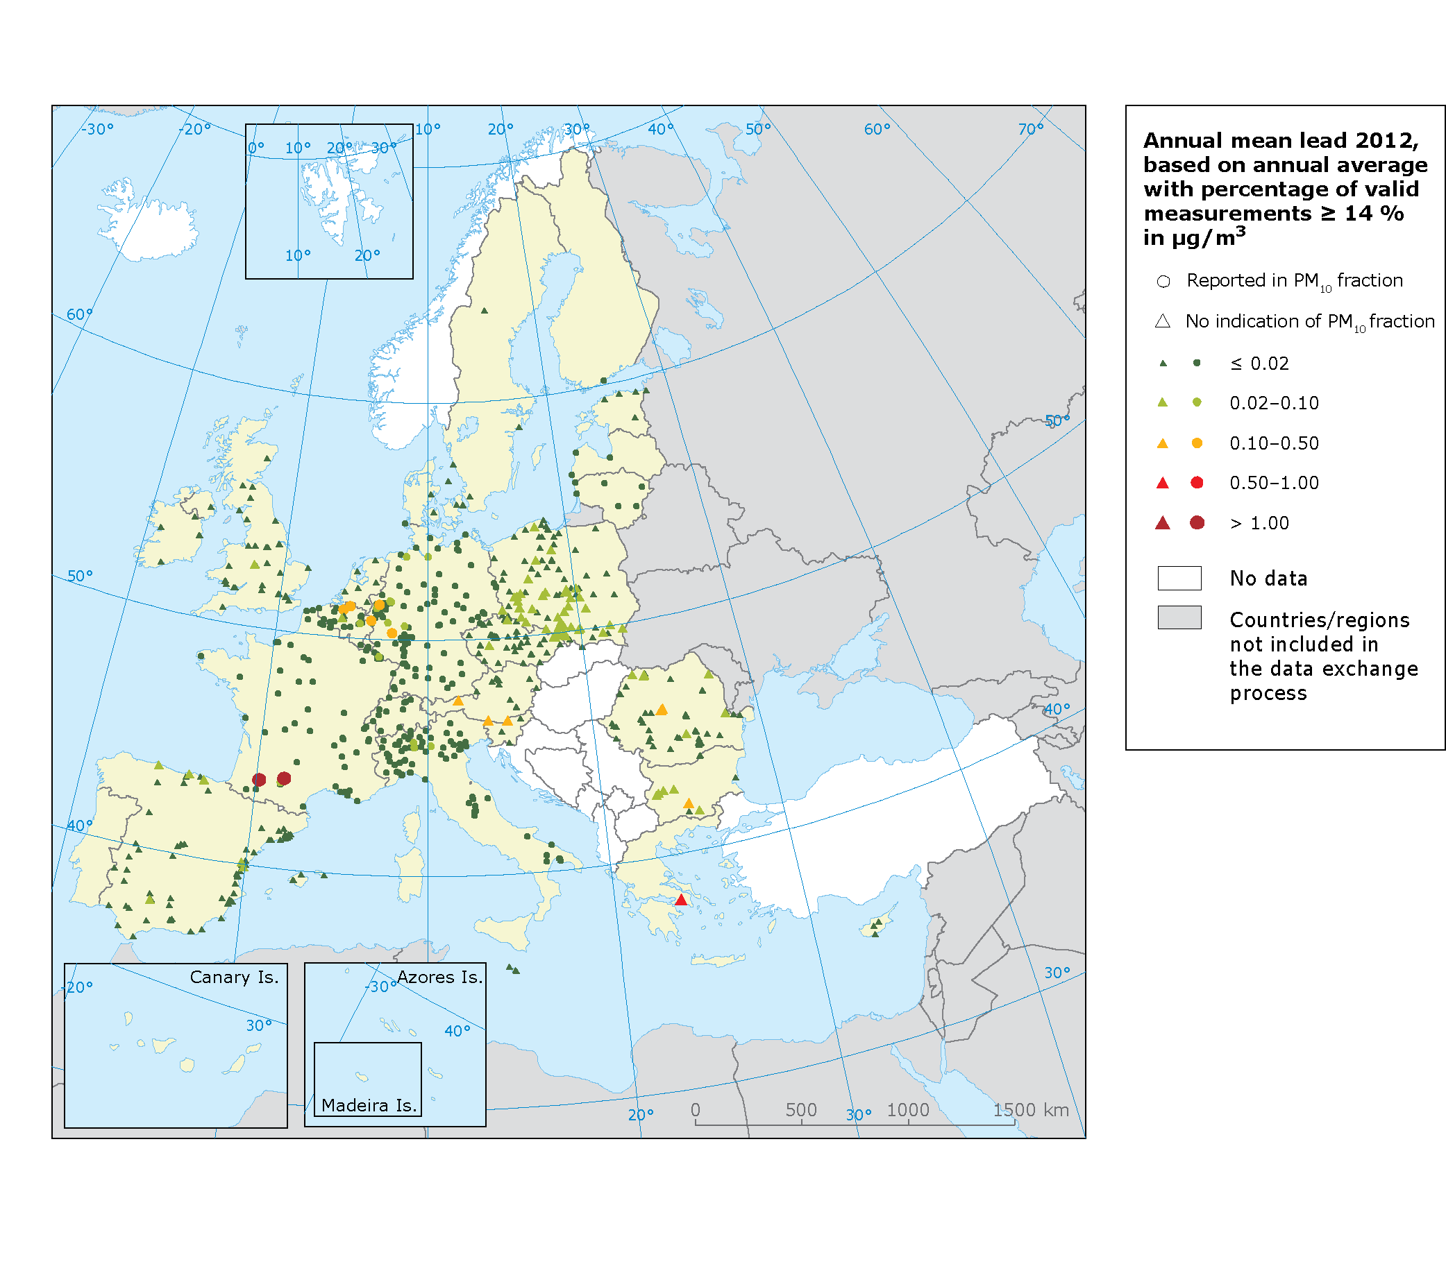
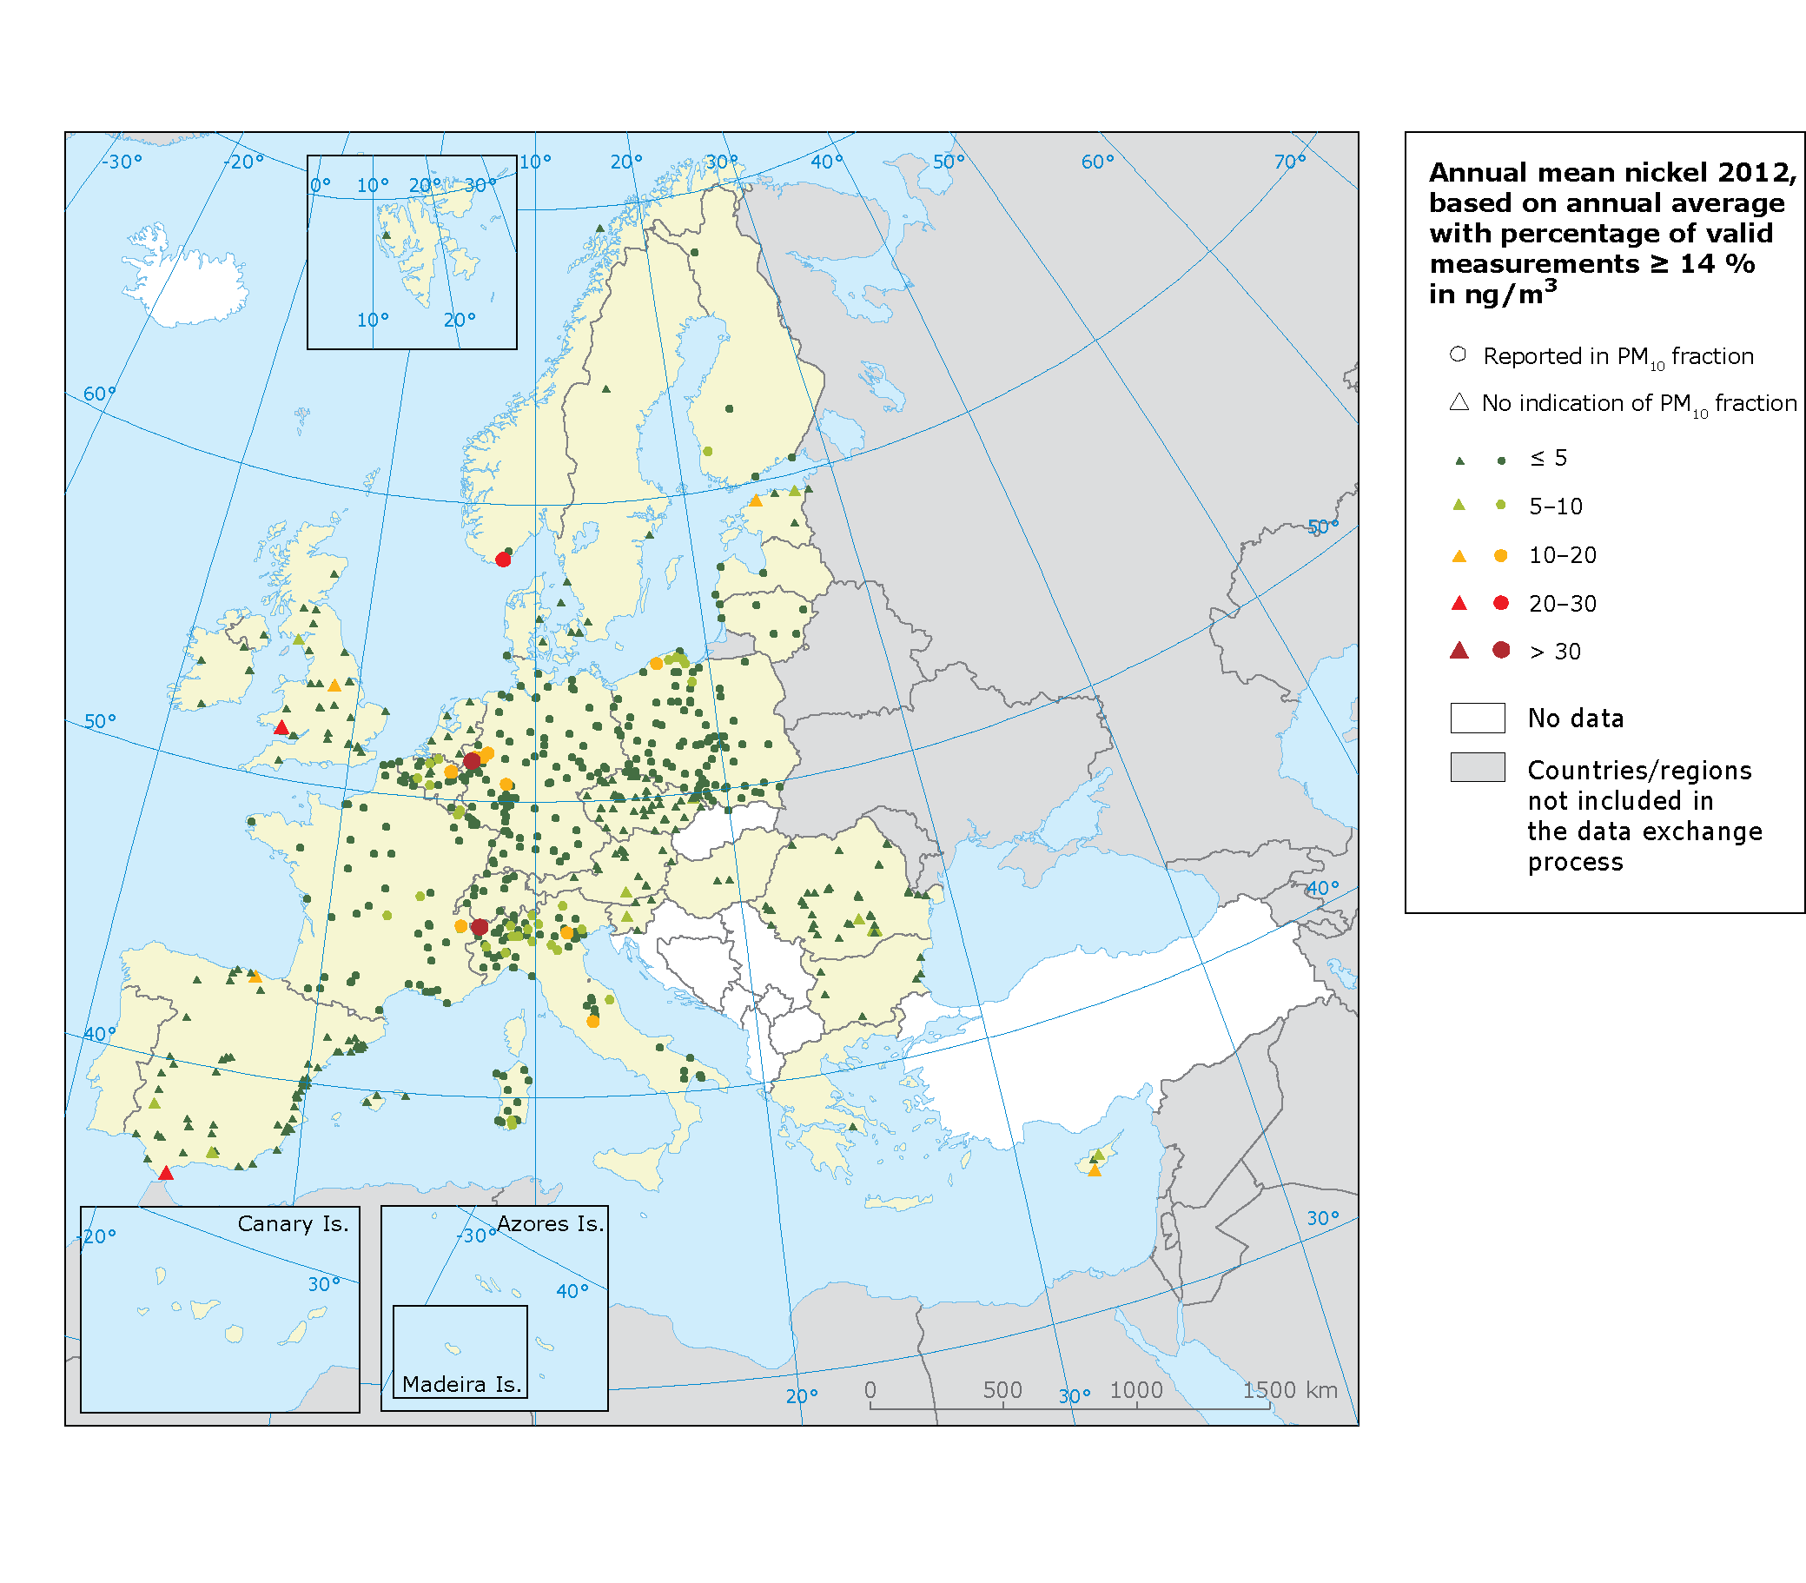
Note: Red and dark red dots correspond to concentrations exceeding the target or limit values: 6 ng/m³ for As, 5 ng/m³ for Cd, 20 ng/m³ for Ni, and 0.5 $µ$g/m³ for Pb.
Source: Airbase v.8

Map 4.8 Concentrations of benzene in 2012
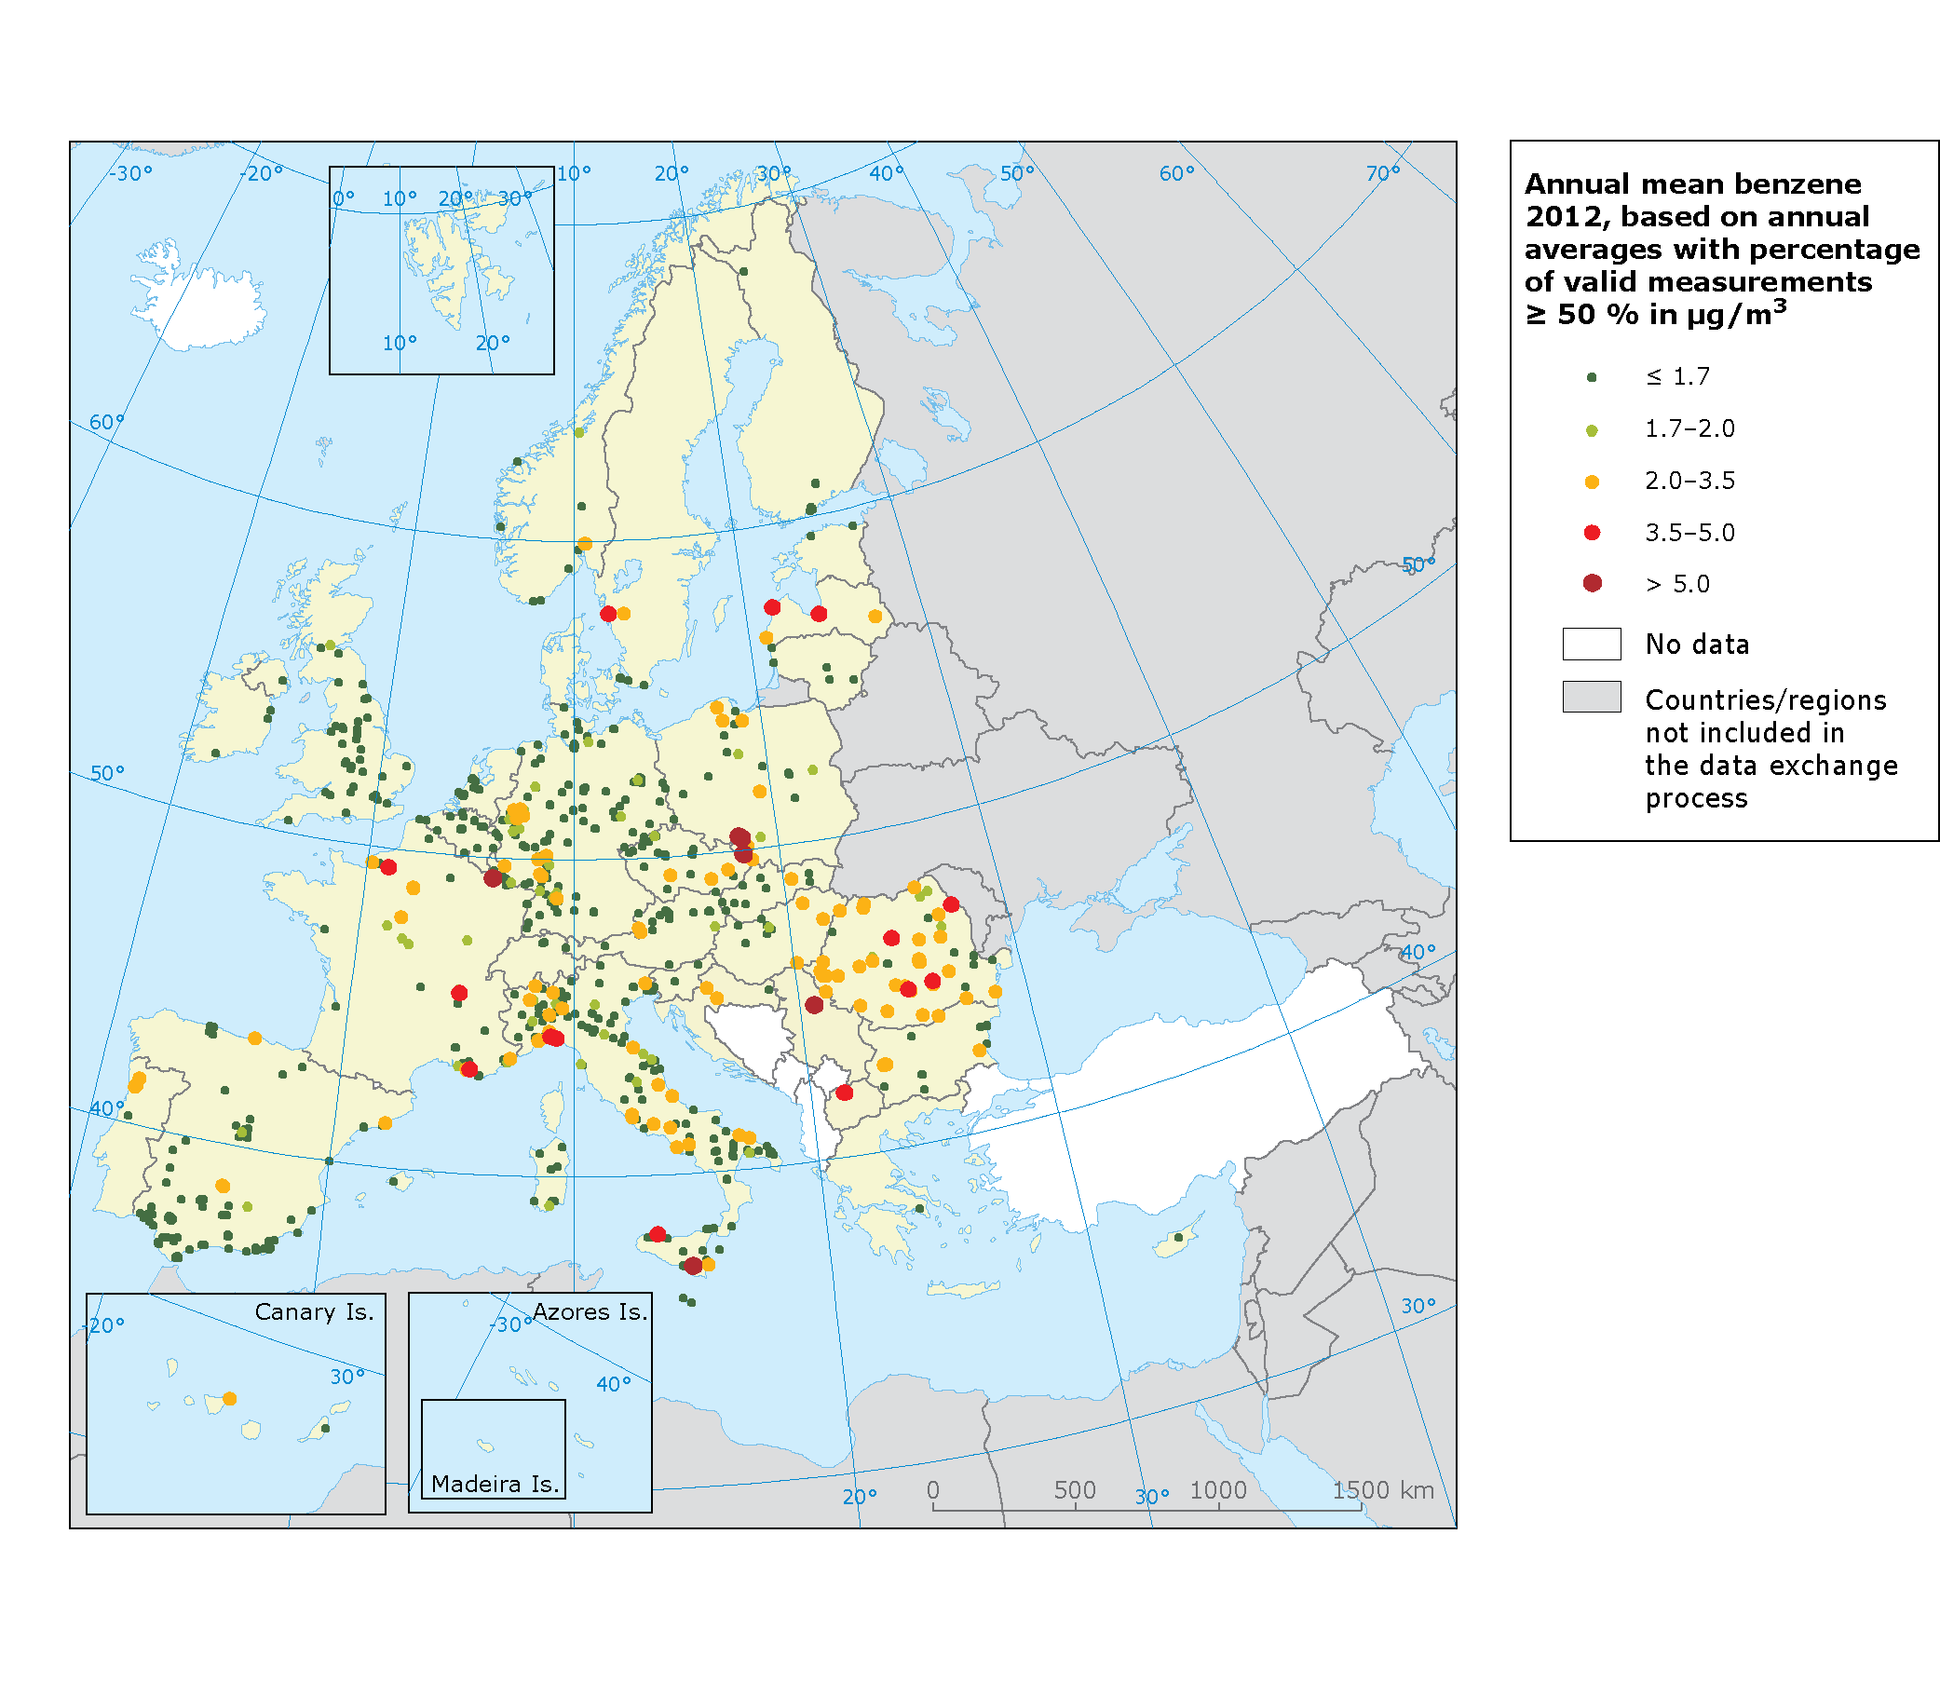
Note: Dark green dots correspond to concentrations under the WHO reference level (1,7μg/m³).
Pale green dots correspond to concentrations under the lower assessment threshold (2 μg/m³).
Orange dots correspond to concentrations under the upper assessment threshold (3.5 μg/m³).
Red dots correspond to concentrations under the limit value of 5 μg/m³.
Dark red dots correspond to concentrations exceeding the limit value of 5 μg/m³.
The data coverage criterion has been set to 50 % by an European Commission working group on benzene (Mol et al., 2011).
Source: AirBase v. 8

Figure 4.2: Attainment situation for PM₁₀ in 2012 in EU28

Note: Unit is µg/m³. The graph is based on the 90.4 percentile of daily mean concentration values corresponding to the 36th highest daily mean for each Member State. For each country the lowest, the highest and averaged value observed (in µg/m³) at the stations is given. At 25% of the stations observed levels are below the indicated lower percentile; at 25% of the station concentrations are above the upper percentile. The limit value set by EU legislation is marked by the red line.

Source: ETC/ACM

Figure 4.3: Attainment situation for PM_{2.5} in 2012 in EU28
0
10
20
30
40
50
SE
EE
FI
PT
ES
LU
DK
GB
LT
DE
NL
MT
BE
AT
FR
LV
SI
GR
HU
IT
CZ
RO
SK
BG
CY
PL
HR
IE
PM2.5 annual limit value

Note: Unit is µg/m³. The graphs are based on annual mean concentration values. For each country the lowest, the highest and averaged value observed (in µg/m³) at the stations is given. At 25% of the stations observed levels are below the indicated lower percentile; at 25% of the station concentrations are above the upper percentile. The limit value set by EU legislation is marked by the red line.

Source: ETC/ACM

Figure 4.4 Trends in PM₁₀ (top graph, 2003–2012) and PM_{2.5} (bottom graph, 2006–2012) annual concentrations per station type

Note: Unit is µg/m³/yr. The graphs are based on annual mean concentration trends for PM10 (top) and PM2.5 (bottom); they present the range of concentration changes per year (in µg/m³) per station type (urban, traffic, rural and other - mostly industrial). The trends are calculated based on the officially reported data by the EU Member States with a minimum data coverage of 75% of valid data per year, for at least 8 out of the 10 years period for PM10 and for at least 5 out of the 6 years period for PM2.5. In 2006, France introduced a nation-wide system to correct PM₁₀ measurements. French PM₁₀ data prior to 2007 have been corrected here using station-type dependent factors (de Leeuw and Fiala, 2009).
The diagram indicates the lowest and highest trends, the means and the lower and upper quartiles, per station type. The lower quartile splits the lowest 25% of the data and the upper quartile splits the highest 25% of the data.
Source: ETC/ACM

Figure 4.5 Urban PM_{2.5} concentrations presented as 3 years average in EU28, 2010-2012

Note: Unit is µg/m³. The three-year running mean of PM_{2.5} concentrations is calculated as the average over all operational (sub)urban background stations within a Member State in the period 2010-2012.

Source: ETC/ACM

Figure 4.6 Attainment situation for O₃ in 2012 in EU28

Note: Unit is µg/m³. The graph is based on the 93.2 percentile of maximum daily 8 hours mean concentration values corresponding to the 26th highest daily maximum of the running 8h-mean for each Member State. For each country the lowest, the highest and averaged value observed (in µg/m³) at the stations is given. At 25% of the stations observed levels are below the indicated lower percentile; at 25% of the station concentrations are above the upper percentile. The limit value set by EU legislation is marked by the red line.

Source: ETC/ACM

Figure 4.7 Trends in O₃ concentrations (2003–2012) per station type.

Note: Unit is µg/m³/yr. The graph is based on the 93.2 percentile of the maximum daily 8-hour O₃concentration trends; it presents the range of concentration changes per year (in µg/m³) per station type (T= traffic, U=Urban/Suburban, R=Rural). The trends are calculated based on the officially reported data by the EU Member States with a minimum data coverage of 75% of valid data per year for at least 8 years out of the 10 years period.
The diagram indicates the lowest and highest trends, the means and the lower and upper quartiles, per station type. The lower quartile splits the lowest 25% of the data and the upper quartile splits the highest 25% of the data.
Source: ETC/ACM

Figure 4.8: Attainment situation for annual limit value of NO₂ in in 2012 in EU28

Note: Unit is µg/m³. The graph is based on the annual mean concentration values for each Member State. For each country the lowest, the highest and averaged value observed (in µg/m³) at the stations is given. At 25% of the stations observed levels are below the indicated lower percentile; at 25% of the station concentrations are above the upper percentile. The limit value set by EU legislation is marked by the red line.

Source: ETC/ACM

Figure 4.9 Trend in NO₂ annual mean (2003–2012) per station type

Note: Unit is µg/m³/yr. The graph is based on annual mean concentration trends; they presents the range of concentration changes per year (in µg/m³) per station type (urban, traffic, rural, and other - mostly industrial). The trends are calculated based on the officially reported data by the EU Member States with a minimum data coverage of 75% of valid data per year for at least 8 years out of the 10 years period.
The diagram indicates the lowest and highest trends, the means and the lower and upper quartiles, per station type. The lower quartile splits the lowest 25% of the data and the upper quartile splits the highest 25% of the data.
Source: ETC/ACM

Figure 4.10 Attainment situation for annual mean concentration of BaP in 2012 in EU28

Note: Unit is µg/m³. The graph is based on the annual mean concentration values for each Member State. For each country the lowest, the highest and averaged value observed (in µg/m³) at the stations is given. At 25% of the stations observed levels are below the indicated lower percentile; at 25% of the station concentrations are above the upper percentile. The limit value set by EU legislation is marked by the red line.

Source: ETC/ACM

Table 4.4 Premature deaths attributable to PM2.5 and O₃ exposure in 2011 in 40 European countries and the EU28
 |  |  | PM2.5 |  |  |  | Ozone
Country |  | population | annual mean | reference | low | high | SOMO35 | reference | low | high
AT | 8045346 |  | 16.3 | 6768 | 4450 | 8899 | 5452 | 309 | 149 | 458
BE | 10325029 |  | 17.3 | 10304 | 6776 | 13547 | 2714 | 220 | 106 | 326
BG | 8117809 |  | 18.3 | 10806 | 7131 | 14161 | 5215 | 425 | 205 | 629
CY | 886301 |  | 21.0 | 710 | 468 | 929 | 8773 | 41 | 20 | 61
CZ | 10234773 |  | 18.8 | 10872 | 7166 | 14262 | 4743 | 376 | 182 | 557
DE | 82201457 |  | 14.8 | 69762 | 45754 | 91947 | 3668 | 2342 | 1131 | 3469
DK | 5394271 |  | 12.5 | 3979 | 2603 | 5257 | 2752 | 117 | 57 | 174
EE | 1343899 |  | 8.0 | 647 | 421 | 859 | 2516 | 27 | 13 | 40
ES | 39113763 |  | 11.1 | 25046 | 16365 | 33127 | 5858 | 1772 | 857 | 2625
FI | 5174350 |  | 7.4 | 2046 | 1331 | 2717 | 2052 | 74 | 36 | 110
FR | 58494279 |  | 15.3 | 46339 | 30418 | 61024 | 4439 | 1829 | 884 | 2709
GR | 10939253 |  | 16.8 | 10700 | 7037 | 14066 | 9182 | 796 | 385 | 1179
HU | 10186452 |  | 23.1 | 15952 | 10554 | 20852 | 5828 | 556 | 269 | 824
IE | 3740194 |  | 7.9 | 1229 | 800 | 1631 | 1353 | 28 | 14 | 42
IT | 56769828 |  | 19.8 | 64544 | 42650 | 84475 | 7532 | 3377 | 1633 | 5001
LT | 3493293 |  | 12.7 | 2556 | 1672 | 3376 | 3131 | 85 | 41 | 126
LU | 446716 |  | 13.3 | 284 | 186 | 375 | 3527 | 10 | 5 | 15
LV | 2393215 |  | 11.1 | 1789 | 1169 | 2367 | 2708 | 58 | 28 | 86
MT | 394641 |  | 15.6 | 247 | 162 | 326 | 7127 | 15 | 7 | 23
NL | 15942494 |  | 17.1 | 12634 | 8305 | 16617 | 2283 | 229 | 111 | 340
PL | 38193972 |  | 21.8 | 42412 | 28051 | 55460 | 4065 | 1100 | 531 | 1629
PT | 9876540 |  | 10.5 | 5707 | 3726 | 7553 | 4552 | 330 | 159 | 488
RO | 22325418 |  | 20.5 | 28582 | 18870 | 37437 | 3276 | 633 | 306 | 938
SE | 8879647 |  | 8.1 | 4221 | 2749 | 5600 | 2628 | 181 | 87 | 268
SI | 1968954 |  | 19.4 | 1938 | 1278 | 2543 | 7062 | 97 | 47 | 143
SK | 5417705 |  | 21.8 | 6300 | 4163 | 8245 | 6051 | 243 | 117 | 360
UK | 59050805 |  | 12.4 | 39450 | 25809 | 52116 | 1471 | 634 | 306 | 940
AD | 82833 |  | 13.7 | 51 | 34 | 67 | 7891 | 4 | 2 | 6
AL | 3613517 |  | 17.2 | 2042 | 1344 | 2684 | 7769 | 129 | 62 | 191
BA | 4558292 |  | 17.2 | 3412 | 2246 | 4483 | 5702 | 154 | 75 | 229
CH | 7687824 |  | 12.6 | 4394 | 2876 | 5803 | 5435 | 256 | 124 | 378
HR | 4440678 |  | 19.6 | 5437 | 3586 | 7128 | 6470 | 246 | 119 | 365
IS | 294964 |  | 4.6 | 54 | 35 | 72 | 1094 | 2 | 1 | 3
LI | 37372 |  | 8.5 | 16 | 10 | 21 | 5128 | 1 | 1 | 2
MC | 52324 |  | 16.4 | 29 | 19 | 38 | 8354 | 2 | 1 | 3
ME | 671451 |  | 15.1 | 482 | 317 | 634 | 6970 | 31 | 15 | 45
MK | 2071302 |  | 15.8 | 1763 | 1158 | 2319 | 7110 | 108 | 52 | 160
NO | 4629088 |  | 6.3 | 1473 | 958 | 1957 | 2395 | 74 | 36 | 110
RS | 9212284 |  | 21.2 | 13063 | 8640 | 17083 | 5793 | 495 | 239 | 733
SM | 27602 |  | 14.7 | 25 | 16 | 33
All | 516729933 |  |  | 458065 | 301304 | 602092 |  | 17407 | 8413 | 25782
EU28 | 487038228 |  |  | 430219 | 282943 | 565573 |  | 16160 | 7810 | 23937

Table 5.1 Effects of air pollutants on the environment
Pollutant | Environmental effects
Particulate matter (PM) | Can affect animals in the same way as humans. Affects plant growth and ecosystem processes.  Can cause damage and soiling of buildings.  Reduced visibility.
Ozone (O₃) | Damages vegetation, impairing plant reproduction and growth, and decreasing crop yields. Can alter ecosystem structure, reduce biodiversity and decrease plant uptake of CO₂.
Nitrogen oxides (NO_{X}) | Contributes to the acidification and eutrophication of soil and water, leading to changes in species diversity. Acts as a precursor of ozone and particulate matter, with associated environmental effects. Can lead to damage to buildings.
PAHs, in particular Benzo-a-pyrene (BaP) | Is toxic to aquatic life and birds. Bioaccumulates, especially in invertebrates.
Sulphur oxides (SO_{X}) | Contributes to the acidification of soil and surface water. Causes injury to vegetation and local species losses in aquatic and terrestrial systems. Contributes to the formation of particulate matter with associated environmental effects. Damages buildings.
Carbon monoxide (CO) | May affect animals in the same way as humans. Acts as a precursor of ozone.
Arsenic | Highly toxic to aquatic life, birds and land animals. Soil with high arsenic content, reduces plant growth and crop yields. Organic arsenic compounds are persistent in the environment and subject to bioaccumulation.
Cadmium | Toxic to aquatic life. Cadmium is highly persistent in the environment and bioaccumulates.
Lead | Bioaccumulates and adversely impacts both terrestrial and aquatic systems. Effects on animal life include reproductive problems and changes in appearance or behaviour.
Mercury | Bioaccumulates and adversely impacts both terrestrial and aquatic systems. Can affect animals in the same way as humans. Very toxic to aquatic life.
Nickel | Nickel and its compounds can have highly acute and chronic toxic effects on aquatic life.  Can affect animals in the same way as humans.
Benzene | Has an acute toxic effect on aquatic life. It bioaccumulates, especially in invertebrates. Leads to reproductive problems and changes in appearance or behaviour. It can damage leaves of agricultural crops and cause death in plants.

Table 5.2 Summary of air quality directive critical levels, target values and long-term objectives for the protection of vegetation

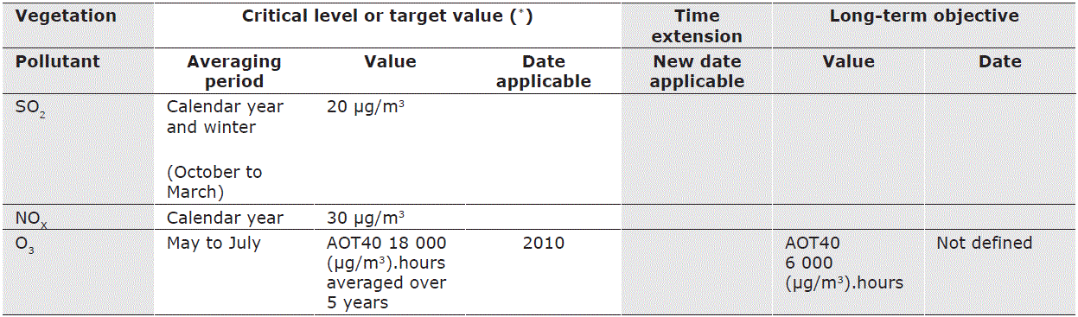
Note: AOT40 is an accumulated ozone exposure, expressed in (μg/m3).hours. The metric is the sum of the amounts by which hourly mean ozone concentrations (in μg/m3) exceed 80 μg/m3 from 08.00 to 20.00 Central European Time each day, accumulated over a given period (usually three summer months). The target value given in the air quality legislation is 18 000 (μg/m3).hours and the long-term objective is 6 000 (μg/m3).hours. (*) See EC, 2008a for definition of legal terms (Article 2).
Source: EC, 2008c

Figure 5.1 Exposure of agricultural area (top) and exposure of forest area (bottom) to ozone (AOT40 in μg/m³.h) in the EEA-33 member countries in the period 2002/04 - 2011.

Top figure: In the Air Quality Directive (2008/50/EC) the target value for protection of vegetation is set to 18 000 (µg/m³).h while the long-term objective is set to 6 000 (µg/m³).h. Due to lack of detailed land cover data and/or rural O₃ data Iceland and Norway were not included until 2006. Switzerland has not been included in the analysis for the period 2004–2007 due to the same reasons. Due to lack of data Turkey is not included during the entire period (2004-2010).
Bottom figure: LRTAP/UNECE has set a critical level for protection of forest to 10 000 (µg/m³).h. Since 2004 a growing number of EEA member countries have been included. In 2004 Bulgaria, Greece, Iceland, Norway, Romania, Switzerland and Turkey have not been included. In 2005-2006 Iceland, Norway, Switzerland and Turkey are still excluded in the analyses due to lack of detailed land cover data and/or rural O₃ data. In 2007 data for Switzerland and Turkey are still missing. Since 2008 only Turkey is not included. Calculations of forest exposure are not available for years prior to 2004.

Source: EEA, 2014b (CSI 005).

Map 5.1 Exposure of European agricultural areas to ozone (AOT40) in 2011
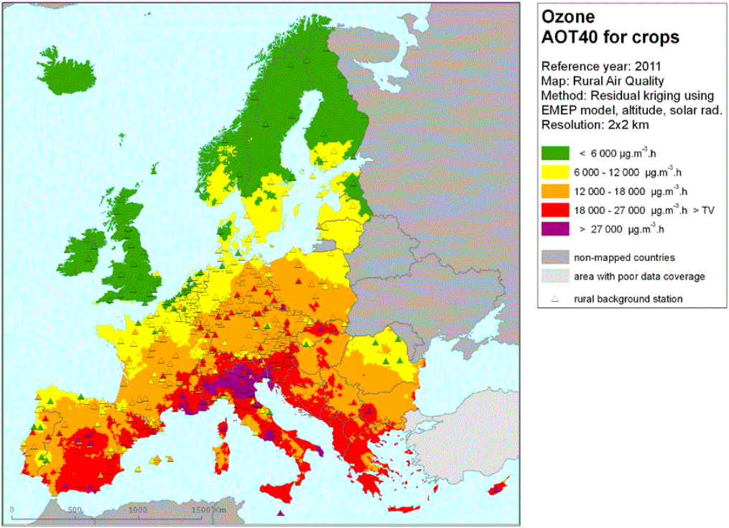
Source: EEA, 2014b (CSI 005) / (Horalek et al, 2013)

Map 5.2 Exposure of European forest areas to ozone (AOT40) in 2011
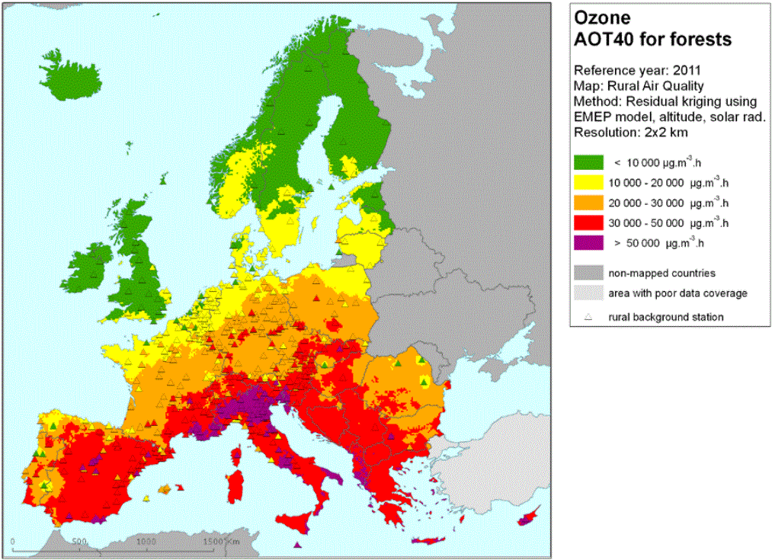
Source: EEA, 2014b (CSI 005) / (Horalek et al, 2013)

Map 5.3 Exposure of European ecosystems and Natura 2000 areas to NOx in 2011
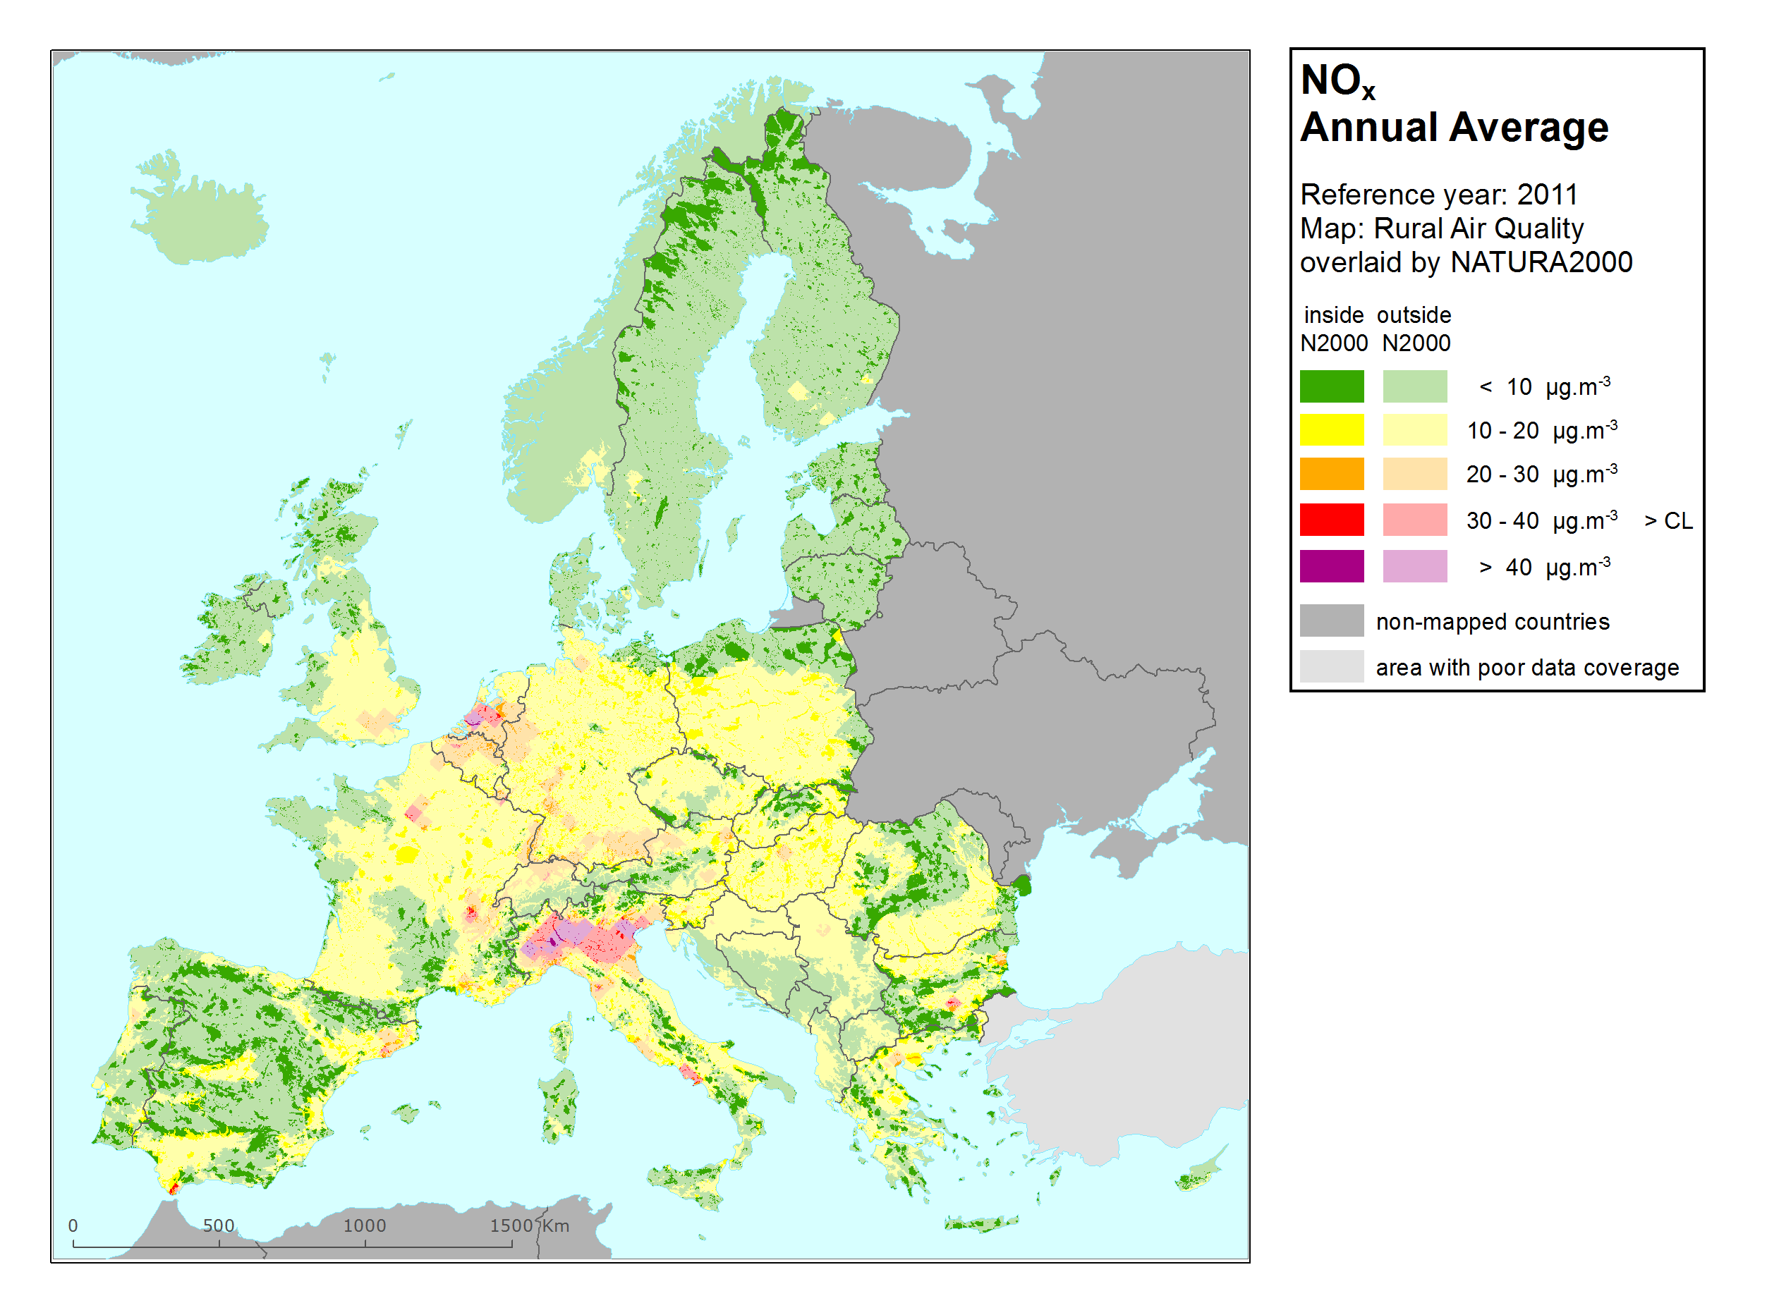

Table 6.1 Effects of air pollutants on climate

Pollutant | Climate effects
Particulate matter (PM) | Climate effect varies depending on particle size and composition: some lead to net cooling, while others lead to warming. Can lead to changed rainfall patterns. Deposition can lead to changes in surface albedo (the ability of the earth to reflect radiation from sunlight).
Ozone (O₃) | Ozone is a greenhouse gas contributing to warming of the atmosphere.
Nitrogen oxides (NO_{X}) | Contributes to the formation of ozone and particulate matter, with associated climate effects.
Sulphur oxides (SO_{X}) | Contributes to the formation of sulphate particles, cooling the atmosphere.
Carbon monoxide (CO) | Contributes to the formation of greenhouse gases such as CO₂ and ozone.
Benzene | Benzene might give a small contribution to radiative forcing as it contributes to the formation of ozone (positive forcing) and secondary organic aerosols.

Table A1.1 Average trends of PM10 annual mean concentrations and 95% confidence limits (μg.m⁻³/yr) by country and by station type, period 2003-2012
 | (sub)urban background |  |  |  | (sub)urban traffic |  |  |  | rural background
Country | Ntot | Nsig | trend | 2σ | Ntot | Nsig | trend | 2σ | Ntot | Nsig | trend | 2σ
All | 542 | 248 | -0.69 | 0.06 | 291 | 173 | -0.98 | 0.08 | 138 | 66 | -0.52 | 0.08
All MS | 527 | 241 | -0.69 | 0.06 | 277 | 164 | -0.99 | 0.08 | 131 | 60 | -0.51 | 0.08
AT | 25 | 15 | -0.66 | 0.15 | 18 | 8 | -0.68 | 0.24 | 9 | 4 | -0.51 | 0.25
BE | 16 | 7 | -0.96 | 0.33 | 6 | 5 | -1.09 | 0.36 | 4 | 0 | -0.77 | 0.73
BG | 8 | 2 | -0.90 | 1.10 | 3 | 0 | -0.35 | 2.13
CH | 11 | 6 | -0.62 | 0.17 | 7 | 6 | -0.76 | 0.18 | 7 | 6 | -0.70 | 0.18
CZ | 46 | 12 | -0.91 | 0.24 | 20 | 7 | -1.11 | 0.37 | 18 | 3 | -0.68 | 0.35
DE | 123 | 62 | -0.60 | 0.08 | 74 | 51 | -0.93 | 0.12 | 50 | 26 | -0.46 | 0.10
ES | 28 | 18 | -1.34 | 0.28 | 30 | 19 | -1.52 | 0.31 | 15 | 11 | -0.52 | 0.18
FI | 5 | 2 | -0.21 | 0.14 | 14 | 9 | -0.41 | 0.09 | 1 | 0 | 0.12 | 0.33
FR | 148 | 65 | -0.55 | 0.07 | 27 | 18 | -0.82 | 0.19 | 7 | 3 | -0.52 | 0.35
GB | 3 | 2 | -1.00 | 0.53 | 3 | 2 | -0.55 | 0.56
GR | 3 | 2 | -1.68 | 1.03 | 1 | 1 | -2.71 | 2.72
HU | 9 | 3 | -0.36 | 0.66 | 5 | 1 | -0.24 | 0.71
IE | 3 | 3 | -0.52 | 0.27 | 2 | 1 | -0.79 | 0.84
IS | 1 | 1 | -1.81 | 1.84 | 1 | 0 | -0.07 | 0.87
IT | 35 | 24 | -1.35 | 0.25 | 37 | 18 | -0.95 | 0.24 | 6 | 3 | -0.28 | 0.42
LT | 3 | 0 | -0.03 | 0.82 | 4 | 1 | -0.72 | 0.77
NL | 5 | 4 | -0.93 | 0.40 | 10 | 7 | -0.87 | 0.24 | 15 | 8 | -0.62 | 0.19
NO | 2 | 0 | -0.47 | 0.66 | 6 | 3 | -1.02 | 0.31
PL | 35 | 5 | 0.13 | 0.40 | 2 | 0 | 0.20 | 1.41 | 2 | 1 | 1.08 | 0.95
PT | 12 | 6 | -1.26 | 0.44 | 13 | 11 | -2.18 | 0.41 | 3 | 1 | -0.83 | 0.94
RO | 2 | 2 | -2.06 | 1.10
RS | 1 | 0 | -0.14 | 4.04
SE | 3 | 2 | -0.56 | 0.32 | 4 | 4 | -1.40 | 0.43
SI | 3 | 3 | -1.51 | 0.59 | 1 | 1 | -1.96 | 0.89 | 1 | 0 | -0.34 | 0.64
SK | 12 | 2 | -0.48 | 0.48 | 3 | 0 | -0.50 | 1.21

- At three stations parallel measurements have been made using gravimetry and beta attenuation; the time series using the non-reference method have been excluded.

Note: Ntot is the number of monitoring stations used to calculate the average trend;
Nsig is the number off monitoring station where a significant trend (p< 0.1) has been observed.
A consistent set used in the calculations: that is, station operation during at least 8 years and having for each year data coverage of 75% or more.

National trends are calculated by averaging the trends estimated at individual stations.
Stations located outside continental Europe (French overseas department, Canary Island, Azores, Madeira are excluded). Only countries included in the consistent set have been listed in the table.

Source: Airbase v. 8

Table A1.2 Average trends of PM10 90.4 percentile concentrations and 95% confidence limits (μg.m⁻³/yr) by country and by station type, period 2003-2012

 | (sub)urban background |  |  |  | (sub)urban traffic |  |  |  | rural background
Country | Ntot | Nsig | trend | 2σ | Ntot | Nsig | trend | 2σ | Ntot | Nsig | trend | 2σ
All | 542 | 198 | -0.91 | 0.12 | 291 | 147 | -1.51 | 0.16 | 138 | 53 | -0.75 | 0.17
All MS | 527 | 191 | -0.91 | 0.12 | 277 | 139 | -1.51 | 0.17 | 131 | 49 | -0.73 | 0.18
AT (a) | 25 | 11 | -1.05 | 0.34 | 18 | 6 | -1.14 | 0.50 | 9 | 2 | -0.88 | 0.52
BE | 16 | 4 | -0.95 | 0.74 | 6 | 3 | -1.15 | 0.75 | 4 | 0 | -1.06 | 1.56
BG | 8 | 2 | -1.49 | 2.62 | 3 | 1 | -1.26 | 5.02
CH | 11 | 6 | -0.90 | 0.42 | 7 | 5 | -1.21 | 0.45 | 7 | 4 | -0.96 | 0.45
CZ | 46 | 7 | -1.20 | 0.54 | 20 | 5 | -1.67 | 0.81 | 18 | 2 | -0.72 | 0.83
DE | 123 | 38 | -0.82 | 0.16 | 74 | 41 | -1.35 | 0.25 | 50 | 19 | -0.68 | 0.22
ES | 28 | 24 | -2.37 | 0.44 | 30 | 18 | -2.53 | 0.54 | 15 | 13 | -1.15 | 0.32
FI | 5 | 1 | -0.35 | 0.32 | 14 | 9 | -0.88 | 0.25 | 1 | 0 | 0.29 | 0.63
FR | 148 | 48 | -0.54 | 0.12 | 27 | 10 | -0.80 | 0.37 | 7 | 2 | -0.38 | 0.60
GB | 3 | 3 | -1.39 | 0.83 | 3 | 2 | -1.26 | 1.43
GR | 3 | 2 | -3.19 | 1.83 | 1 | 1 | -4.20 | 4.48
HU | 9 | 1 | -0.42 | 1.36 | 5 | 1 | -0.39 | 1.44
IE | 3 | 1 | -0.91 | 0.88 | 2 | 1 | -1.42 | 1.49
IS | 1 | 1 | -2.69 | 2.69 | 1 | 0 | -0.56 | 1.80
IT | 35 | 21 | -2.35 | 0.50 | 37 | 17 | -1.38 | 0.60 | 6 | 2 | -0.48 | 0.81
LT | 3 | 0 | -0.16 | 1.87 | 4 | 2 | -1.33 | 1.17
NL | 5 | 2 | -1.31 | 0.80 | 10 | 5 | -1.15 | 0.49 | 15 | 6 | -0.96 | 0.38
NO | 2 | 0 | -0.58 | 1.71 | 6 | 3 | -1.95 | 0.76
PL | 35 | 9 | 1.06 | 0.91 | 2 | 0 | 1.47 | 3.23 | 2 | 2 | 2.47 | 2.30
PT | 12 | 9 | -2.64 | 0.81 | 13 | 12 | -3.86 | 0.81 | 3 | 1 | -1.66 | 1.75
RO | 2 | 2 | -3.41 | 2.57
RS | 1 | 0 | 1.93 | 9.57
SE | 3 | 2 | -0.69 | 0.57 | 4 | 4 | -3.47 | 1.30
SI | 3 | 2 | -1.87 | 1.06 | 1 | 1 | -1.49 | 2.02 | 1 | 0 | 0.04 | 1.87
SK | 12 | 2 | -0.35 | 0.83 | 3 | 0 | -0.56 | 2.23
(a) At three stations parallel measurements have been made using gravimetry and beta attenuation; the time series using the non-reference method have been excluded.

Note: Ntot is the number of monitoring stations used to calculate the average trend;
Nsig is the number off monitoring station where a significant trend (p< 0.1) has been observed.
A consistent set used in the calculations: that is, station operation during at least 8 years and having for each year data coverage of 75% or more.

National trends are calculated by averaging the trends estimated at individual stations.
Stations located outside continental Europe (French overseas department, Canary Island, Azores, Madeira are excluded). Only countries included in the consistent set have been listed in the table.

Source: Airbase v. 8

Table A1.3 Average trends of PM2.5 annual mean concentrations and 95% confidence limits (μg.m⁻³/yr) by country and by station type, period 2006-2012

 | (sub)urban background |  |  |  | (sub)urban traffic |  |  |  | rural background
Country | Ntot | Nsig | trend | 2σ | Ntot | Nsig | trend | 2σ | Ntot | Nsig | trend | 2σ
All | 61 | 6 | -0.02 | 0.23 | 47 | 20 | -0.39 | 0.21 | 22 | 4 | 0.07 | 0.34
All MS | 60 | 6 | -0.01 | 0.24 | 40 | 17 | -0.36 | 0.24 | 22 | 4 | 0.07 | 0.34
AT | 1 | 0 | -0.44 | 1.38 | 3 | 2 | -0.91 | 0.74 | 1 | 0 | 0.51 | 1.63
BE | 2 | 0 | 0.30 | 0.84 | 2 | 0 | -0.01 | 0.74 | 1 | 0 | 0.91 | 1.36
BG | 1 | 0 | -1.23 | 3.30 |  |  |  |  | 1 | 0 | -0.33 | 0.66
CZ | 16 | 2 | -0.01 | 0.50 | 4 | 2 | -0.51 | 0.79 | 4 | 0 | 0.77 | 1.21
DE | 9 | 0 | -0.32 | 0.54 | 7 | 0 | -0.21 | 0.71 | 4 | 0 | 0.01 | 0.58
DK | 1 | 0 | -0.11 | 1.18 | 1 | 0 | 0.46 | 2.46
EE | 1 | 0 | 0.42 | 2.03
ES | 2 | 2 | -1.38 | 0.72 | 1 | 0 | -0.24 | 1.81 | 3 | 1 | -0.15 | 0.78
FI | 2 | 1 | -0.21 | 0.22 | 2 | 1 | -0.27 | 0.43 | 2 | 0 | 0.10 | 0.61
FR | 15 | 1 | 0.57 | 0.48 | 2 | 0 | 0.57 | 1.58
GB |  |  |  |  | 1 | 1 | -0.66 | 0.81 | 1 | 1 | -0.67 | 0.52
HU | 1 | 0 | 0.93 | 2.55 | 1 | 0 | -0.30 | 1.27
IT | 5 | 0 | -0.89 | 0.79 | 7 | 3 | -0.44 | 0.54 | 1 | 0 | 0.22 | 2.68
LT |  |  |  |  | 2 | 2 | 1.57 | 0.71
MT |  |  |  |  | 1 | 1 | -0.79 | 0.90
NO | 1 | 0 | -0.25 | 0.90 | 7 | 3 | -0.57 | 0.31
PL |  |  |  |  | 1 | 0 | -0.16 | 1.02
PT | 1 | 0 | -0.22 | 1.52 | 2 | 2 | -1.92 | 1.29 | 4 | 2 | -0.47 | 0.73
SE | 1 | 0 | 0.30 | 0.92 | 3 | 3 | -1.15 | 0.67
SK | 2 | 0 | 0.50 | 1.90

Note: Ntot is the number of monitoring stations used to calculate the average trend;
Nsig is the number off monitoring station where a significant trend (p< 0.1) has been observed.
A consistent set used in the calculations: that is, station operation during at least 5 years and having for each year data coverage of 75% or more.

National trends are calculated by averaging the trends estimated at individual stations.
Stations located outside continental Europe (French overseas department, Canary Island, Azores, Madeira are excluded). Only countries included in the consistent set have been listed in the table.

Source: Airbase v. 8

Table A1.4 Average trends of O₃ 93.2 percentile concentrations and 95% confidence limits (μg.m⁻³/yr) by country and by station type, period 2003-2012

 | (sub)urban background |  |  |  | (sub)urban traffic |  |  |  | rural background
Country | Ntot | Nsig | trend | 2σ | Ntot | Nsig | trend | 2σ | Ntot | Nsig | trend | 2σ
All | 716 | 240 | -1.37 | 0.11 | 143 | 41 | -0.33 | 0.25 | 372 | 166 | -1.44 | 0.14
All MS | 703 | 237 | -1.38 | 0.11 | 136 | 40 | -0.32 | 0.26 | 357 | 159 | -1.45 | 0.14
AT | 42 | 5 | -0.85 | 0.32 | 6 | 2 | -0.81 | 1.01 | 44 | 15 | -1.18 | 0.31
BE | 13 | 8 | -2.13 | 0.75 | 4 | 4 | -1.79 | 1.50 | 15 | 10 | -2.40 | 0.73
BG | 6 | 2 | -0.34 | 1.67 | 2 | 1 | 2.30 | 3.64 | 1 | 0 | -1.00 | 2.92
CH | 13 | 3 | -1.16 | 0.83 | 6 | 1 | -0.42 | 0.99 | 10 | 5 | -1.45 | 0.83
CY |  |  |  |  |  |  |  |  | 1 | 0 | -0.30 | 2.45
CZ | 28 | 8 | -1.47 | 0.50 | 5 | 1 | -0.92 | 1.12 | 23 | 10 | -1.71 | 0.54
DE | 132 | 61 | -1.60 | 0.21 | 20 | 8 | -1.04 | 0.48 | 72 | 40 | -1.67 | 0.26
DK | 4 | 1 | -0.02 | 1.10 | 2 | 0 | 0.18 | 1.05 | 2 | 1 | -1.43 | 1.84
EE | 1 | 0 | -0.37 | 3.00 |  |  |  |  | 3 | 1 | -0.90 | 0.85
ES | 54 | 18 | -0.75 | 0.37 | 55 | 18 | -0.02 | 0.35 | 36 | 13 | -0.99 | 0.34
FI | 4 | 0 | -0.36 | 0.84 | 1 | 1 | 0.79 | 1.50 | 10 | 3 | -1.18 | 0.58
FR | 243 | 90 | -1.62 | 0.18 |  |  |  |  | 50 | 30 | -1.98 | 0.39
GB | 38 | 10 | -1.43 | 0.44 | 2 | 0 | -0.12 | 1.70 | 16 | 7 | -1.36 | 0.60
GR | 6 | 2 | -2.27 | 1.24 | 4 | 0 | 0.10 | 1.81 | 1 | 1 | 5.14 | 6.38
HU | 12 | 1 | 0.45 | 1.04 |  |  |  |  | 2 | 0 | 0.75 | 3.73
IE | 1 | 0 | -0.06 | 1.80 | 1 | 1 | -1.82 | 2.03 | 5 | 0 | -0.46 | 0.88
IT | 60 | 20 | -1.33 | 0.55 | 20 | 2 | -0.36 | 1.03 | 17 | 7 | -1.14 | 1.29
LT | 1 | 0 | -0.98 | 3.20 | 2 | 0 | 1.08 | 3.07 | 3 | 0 | -0.55 | 1.03
LU | 1 | 0 | -1.18 | 8.75 |  |  |  |  | 1 | 0 | -1.05 | 2.17
LV |  |  |  |  |  |  |  |  | 1 | 1 | 2.61 | 1.42
MK |  |  |  |  | 1 | 0 | -1.27 | 3.53
NL | 7 | 3 | -2.62 | 1.41 | 4 | 1 | -1.66 | 1.79 | 20 | 13 | -2.09 | 0.60
NO |  |  |  |  |  |  |  |  | 5 | 2 | -1.03 | 0.53
PL | 17 | 1 | -0.75 | 0.67 |  |  |  |  | 13 | 2 | -0.88 | 0.72
PT | 18 | 4 | -0.91 | 0.64 | 5 | 1 | 0.02 | 1.21 | 5 | 0 | -1.76 | 1.92
RO | 1 | 1 | -7.15 | 8.68
SE | 4 | 1 | -1.09 | 1.27 | 1 | 0 | 1.49 | 3.58 | 7 | 2 | -0.84 | 0.65
SI | 4 | 0 | -0.62 | 1.42 | 2 | 0 | 0.18 | 1.78 | 3 | 0 | -0.29 | 1.21
SK | 6 | 1 | -1.28 | 1.22 |  |  |  |  | 6 | 3 | -1.55 | 0.76

Note: Ntot is the number of monitoring stations used to calculate the average trend;
Nsig is the number off monitoring station where a significant trend (p< 0.1) has been observed.
A consistent set used in the calculations: that is, station operation during at least 8 years and having for each year a data coverage of 75% or more.

National trends are calculated by averaging the trends estimated at individual stations.
Stations located outside continental Europe (French overseas department, Canary Island, Azores, Madeira are excluded). Only countries included in the consistent set have been listed in the table.

Source: Airbase v. 8

Table A1.5 Average trends of O₃ mean Summer and Winter concentrations and 95% confidence limits (μg.m⁻³/yr) by country, period 2003-2012
 | Summer |  |  |  |  | Winter
Country | Ntot | Nsig | trend | 2σ |  | Ntot | Nsig | trend | 2σ
All | 1380 | 377 | -1.13 | 0.08 |  | 1254 | 132 | 0.21 | 0.05
All MS | 1344 | 367 | -1.13 | 0.08 |  | 1219 | 126 | 0.21 | 0.05
AT | 101 | 21 | -0.83 | 0.23 |  | 100 | 7 | -0.30 | 0.14
BE | 38 | 15 | -2.04 | 0.45 |  | 36 | 1 | 0.12 | 0.27
BG | 9 | 1 | 0.93 | 1.78 |  | 7 | 3 | 0.50 | 1.57
CH | 29 | 5 | -0.85 | 0.54 |  | 29 | 4 | 0.19 | 0.25
CY | 1 | 0 | 0.22 | 4.06 |  | 1 | 0 | -0.50 | 1.64
CZ | 54 | 15 | -1.19 | 0.32 |  | 46 | 5 | -0.48 | 0.28
DE | 238 | 54 | -1.16 | 0.17 |  | 248 | 16 | 0.28 | 0.10
DK | 7 | 0 | 0.10 | 0.91 |  | 8 | 0 | 0.83 | 0.73
EE | 6 | 0 | 0.26 | 0.80 |  | 6 | 1 | -0.44 | 0.58
ES | 215 | 67 | -0.70 | 0.19 |  | 202 | 35 | 0.53 | 0.16
FI | 16 | 3 | -0.47 | 0.44 |  | 15 | 8 | -0.88 | 0.35
FR | 311 | 99 | -1.72 | 0.17 |  | 291 | 32 | 0.37 | 0.08
GB | 57 | 27 | -1.59 | 0.29 |  | 42 | 2 | -0.07 | 0.33
GR | 14 | 2 | -0.48 | 1.50 |  | 12 | 2 | 0.54 | 0.83
HU | 13 | 2 | 0.85 | 1.20 |  | 7 | 1 | 1.02 | 1.04
IE | 7 | 5 | -1.34 | 0.62 |  | 6 | 0 | -0.26 | 0.61
IT | 115 | 25 | -0.90 | 0.44 |  | 85 | 4 | 0.12 | 0.29
LT | 7 | 1 | -0.33 | 0.65 |  | 7 | 1 | 0.11 | 0.89
LU | 3 | 0 | -0.31 | 3.95 |  | 3 | 0 | 0.50 | 1.92
LV | 3 | 2 | 1.63 | 1.61 |  | 1 | 0 | -1.31 | 8.78
MK | 2 | 1 | -2.55 | 4.48 |  | 1 | 1 | 1.86 | 1.60
NL | 33 | 14 | -1.52 | 0.52 |  | 29 | 0 | 0.25 | 0.41
NO | 5 | 4 | -1.22 | 0.50 |  | 5 | 1 | -0.41 | 0.36
PL | 31 | 4 | -0.56 | 0.53 |  | 15 | 2 | -0.62 | 0.55
PT | 31 | 5 | -1.29 | 0.62 |  | 25 | 5 | 0.51 | 0.46
RO | 2 | 1 | -4.54 | 4.34
SE | 10 | 1 | -0.42 | 0.58 |  | 9 | 1 | -0.19 | 0.84
SI | 10 | 0 | -0.42 | 0.88 |  | 9 | 0 | -0.15 | 0.52
SK | 12.0 | 3.0 | -1.26 | 0.78 |  | 9 | 0 | -0.17 | 0.62

Note:
Summer: June, July August; Winter: December, January, February.
Ntot is the number of monitoring stations used to calculate the average trend;
Nsig is the number off monitoring station where a significant trend (p< 0.1) has been observed.
A consistent set used in the calculations: that is, station operation during at least 8 years and having for each year a data coverage of 75% or more.

National trends are calculated by averaging the trends estimated at individual stations.
Stations located outside continental Europe (French overseas department, Canary Island, Azores, Madeira are excluded). Only countries included in the consistent set have been listed in the table.

Source: Airbase v. 8

Table A1.6 Average trends of NO₂ annual mean concentrations and 95% confidence limits (μg.m⁻³/yr) by country and by station type, period 2003-2012

 | (sub)urban background |  |  |  | (sub)urban traffic |  |  |  | rural background
Country | Ntot | Nsig | trend | 2σ | Ntot | Nsig | trend | 2σ | Ntot | Nsig | trend | 2σ
All | 770 | 379 | -0.48 | 0.03 | 427 | 209 | -0.69 | 0.07 | 256 | 117 | -0.22 | 0.03
All MS | 752 | 368 | -0.47 | 0.03 | 413 | 203 | -0.70 | 0.07 | 244 | 110 | -0.21 | 0.03
AT | 47 | 22 | -0.35 | 0.08 | 33 | 11 | -0.45 | 0.13 | 29 | 4 | -0.04 | 0.06
BA | 1 | 1 | -1.94 | 1.94
BE | 16 | 12 | -0.57 | 0.12 | 10 | 9 | -0.79 | 0.16 | 10 | 10 | -0.56 | 0.12
BG | 7 | 0 | -0.31 | 0.73 | 4 | 1 | -0.22 | 1.16
CH | 12 | 8 | -0.51 | 0.14 | 7 | 4 | -0.59 | 0.22 | 10 | 7 | -0.30 | 0.09
CZ | 39 | 17 | -0.34 | 0.09 | 20 | 12 | -0.72 | 0.25 | 22 | 6 | -0.19 | 0.09
DE | 145 | 59 | -0.35 | 0.05 | 95 | 58 | -0.76 | 0.10 | 67 | 37 | -0.26 | 0.04
DK | 4 | 4 | -0.72 | 0.21 | 5 | 3 | -0.66 | 0.39 | 2 | 0 | -0.19 | 0.21
EE | 1 | 0 | -0.26 | 0.39 |  |  |  |  | 3 | 0 | -0.02 | 0.04
ES | 47 | 22 | -0.55 | 0.16 | 51 | 24 | -0.67 | 0.20 | 22 | 13 | -0.07 | 0.11
FI | 4 | 1 | -0.40 | 0.24 | 9 | 4 | -0.57 | 0.27 | 6 | 2 | -0.07 | 0.09
FR | 236 | 158 | -0.56 | 0.04 | 49 | 25 | -0.74 | 0.15 | 14 | 7 | -0.32 | 0.10
GB | 33 | 12 | -0.22 | 0.17 | 13 | 5 | -0.40 | 0.42 | 9 | 4 | -0.23 | 0.16
GR | 6 | 5 | -1.53 | 0.47 | 5 | 2 | -2.55 | 1.28
HU | 12 | 1 | -0.27 | 0.35 | 6 | 3 | -0.22 | 0.64 | 2 | 1 | 0.38 | 0.30
IE | 1 | 0 | -0.23 | 0.47 | 3 | 0 | -0.10 | 1.45 | 2 | 0 | 0.07 | 0.19
IS | 1 | 1 | -0.87 | 0.72 | 1 | 1 | -0.98 | 0.75
IT | 85 | 39 | -0.76 | 0.18 | 74 | 31 | -0.88 | 0.26 | 14 | 4 | -0.54 | 0.27
LT | 1 | 0 | -0.77 | 0.73 | 1 | 0 | -1.29 | 1.27 | 3 | 2 | -0.02 | 0.07
LU | 1 | 0 | -0.42 | 0.96 | 1 | 1 | 0.72 | 0.75 | 2 | 0 | 0.01 | 0.48
LV | 2 | 0 | -0.10 | 1.43
NL | 8 | 6 | -0.73 | 0.23 | 8 | 8 | -0.95 | 0.23 | 20 | 16 | -0.45 | 0.10
NO | 1 | 0 | -0.49 | 0.86 | 6 | 1 | 0.38 | 0.78 | 2 | 0 | -0.02 | 0.03
PL | 29 | 4 | -0.09 | 0.16 | 4 | 1 | -0.13 | 0.71 | 9 | 1 | 0.13 | 0.12
PT | 16 | 2 | -0.21 | 0.27 | 14 | 3 | -0.22 | 0.25 | 4 | 1 | -0.03 | 0.28
RO |  |  |  |  | 1 | 1 | -4.24 | 4.23
RS | 3 | 1 | -0.93 | 1.51
SE | 4 | 2 | -0.17 | 0.29 | 4 | 1 | -0.18 | 0.33 | 3 | 2 | -0.08 | 0.05
SI | 4 | 0 | 0.09 | 0.42 | 1 | 0 | -0.17 | 0.67 | 1 | 0 | 0.36 | 0.49
SK | 4 | 2 | -0.14 | 1.29 | 2 | 0 | -0.12 | 1.62

Note: Ntot is the number of monitoring stations used to calculate the average trend;
Nsig is the number off monitoring station where a significant trend (p< 0.1) has been observed.
A consistent set used in the calculations: that is, station operation during at least 8 years and having for each year a data coverage of 75% or more.

National trends are calculated by averaging the trends estimated at individual stations.
Stations located outside continental Europe (French overseas department, Canary Island, Azores, Madeira are excluded). Only countries included in the consistent set have been listed in the table.

Source: Airbase v. 8

Table A1.7 Average trends of NO₂ 99.8 percentile hourly concentrations and 95% confidence limits (μg.m⁻³/yr) by country and by station type, period 2003-2012

 | (sub)urban background |  |  |  |  | (sub)urban traffic |  |  |  | rural background
Country | Ntot | Nsig | trend | 2σ | Ntot |  | Nsig | trend | 2σ | Ntot | Nsig | trend | 2σ
All | 773 | 160 | -1.00 | 0.17 | 426 |  | 86 | -1.01 | 0.31 | 244 | 51 | -0.60 | 0.17
All MS | 773 | 160 | -1.00 | 0.17 | 426 |  | 86 | -1.01 | 0.31 | 244 | 51 | -0.60 | 0.17
AT | 758 | 156 | -0.97 | 0.18 | 412 |  | 85 | -1.07 | 0.32 | 234 | 50 | -0.60 | 0.18
BA | 47 | 8 | -1.39 | 0.47 | 33 |  | 2 | -0.60 | 0.64 | 29 | 4 | -0.13 | 0.44
BE | 1 | 1 | -26.38 | 10.37
BG | 15 | 0 | -0.58 | 1.01 | 10 |  | 0 | -0.56 | 1.24 | 9 | 2 | -0.72 | 0.62
CH | 7 | 0 | -3.12 | 5.99 | 4 |  | 0 | 0.48 | 15.16
CZ | 12 | 3 | -0.53 | 0.67 | 7 |  | 0 | -0.82 | 0.92 | 10 | 1 | -0.69 | 0.70
DE | 39 | 9 | -1.64 | 0.68 | 20 |  | 4 | -1.44 | 1.31 | 22 | 2 | -0.72 | 0.85
DK | 145 | 35 | -1.03 | 0.25 | 94 |  | 25 | -1.26 | 0.40 | 67 | 14 | -0.59 | 0.26
EE | 4 | 1 | -0.96 | 1.70 | 5 |  | 0 | 0.18 | 1.73 | 2 | 0 | -0.77 | 1.40
ES | 1 | 0 | -1.00 | 3.64 |  |  |  |  |  | 3 | 0 | 0.37 | 0.87
FI | 50 | 11 | -1.44 | 0.69 | 52 |  | 13 | -0.97 | 0.85 | 22 | 8 | -0.62 | 0.65
FR | 4 | 2 | -2.33 | 1.10 | 9 |  | 0 | -1.13 | 1.62 | 6 | 0 | -0.24 | 1.02
GB | 239 | 49 | -0.63 | 0.21 | 49 |  | 8 | -0.92 | 0.79 | 14 | 9 | -0.98 | 0.53
GR | 32 | 6 | 0.26 | 1.56 | 13 |  | 3 | -0.50 | 1.46 | 9 | 1 | -0.74 | 1.07
HU | 6 | 5 | -6.12 | 1.83 | 5 |  | 4 | -7.28 | 3.21
IE | 12 | 1 | -2.48 | 2.42 | 6 |  | 1 | -1.63 | 3.48 | 1 | 0 | 2.23 | 3.40
IS | 1 | 0 | -0.57 | 1.22 | 3 |  | 0 | -0.48 | 2.97 | 2 | 1 | 0.23 | 1.26
IT | 1 | 0 | -0.43 | 5.83 | 1 |  | 0 | -4.77 | 5.80
LT | 86 | 18 | -1.60 | 0.74 | 74 |  | 16 | -1.29 | 0.93 | 14 | 3 | -1.83 | 1.17
LU | 1 | 0 | -0.89 | 4.78 | 1 |  | 1 | -7.37 | 6.28
LV | 1 | 0 | 0.00 | 3.39 | 1 |  | 0 | 1.67 | 7.01 | 2 | 1 | -0.82 | 1.21
NL | 3 | 0 | 1.98 | 3.63
NO | 8 | 1 | -0.93 | 1.02 | 8 |  | 5 | -2.84 | 1.18 | 20 | 3 | -0.73 | 0.50
PL | 1 | 0 | -0.15 | 3.77 | 6 |  | 1 | 3.52 | 4.44
PT | 28 | 2 | -0.44 | 1.17 | 4 |  | 0 | -0.97 | 2.85 | 7 | 1 | 0.34 | 1.19
SE | 16 | 3 | 1.01 | 1.28 | 14 |  | 2 | 1.06 | 1.53 | 4 | 1 | -0.38 | 1.08
SI | 5 | 3 | 0.22 | 1.50 | 4 |  | 1 | 1.97 | 2.01
SK | 4 | 0 | -0.22 | 2.15 | 1 |  | 0 | -0.24 | 3.82 | 1 | 0 | -0.33 | 2.13

Note: Ntot is the number of monitoring stations used to calculate the average trend;
Nsig is the number off monitoring station where a significant trend (p< 0.1) has been observed.
A consistent set used in the calculations: that is, station operation during at least 8 years and having for each year a data coverage of 75% or more.

National trends are calculated by averaging the trends estimated at individual stations.
Stations located outside continental Europe (French overseas department, Canary Island, Azores, Madeira are excluded). Only countries included in the consistent set have been listed in the table.

Source: Airbase v. 8

NOx, CO and NMVOC emissions where downloaded from EEA Air pollutant emissions data viewer (LRTAP Convention) (http://www.eea.europa.eu/data-and-maps/data/data-viewers/air-emissions-viewer-lrtap) CH₄ emissions where downloaded from EEA greenhouse gas data viewer (http://www.eea.europa.eu/data-and-maps/data/data-viewers/greenhouse-gases-viewer)

