1. 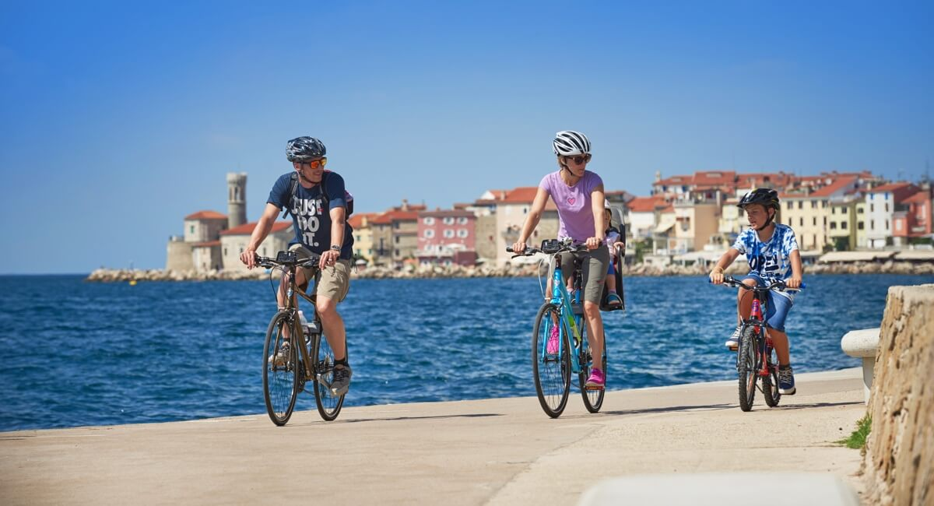
https://www.slovenia.info/sl/destinacije/znamenitosti/piran-s-solinami
oziroma tu: https://www.slovenia.info/uploads/znamenitosti/parenzana-piran-cycling.jpg?1479577008719

2. 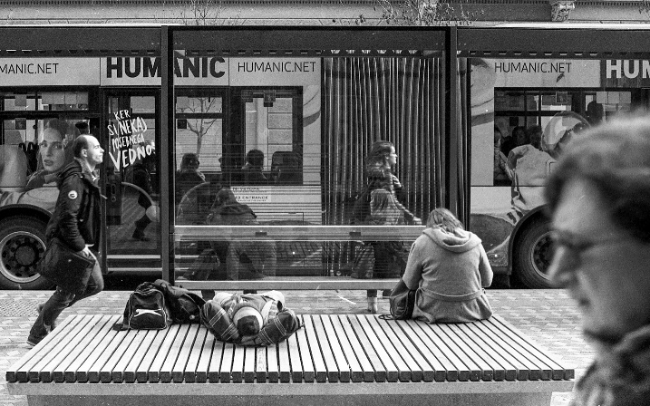
https://www.flickr.com/photos/europeanenvironmentagency/29025719560/in/album-72157673032944826/

3. 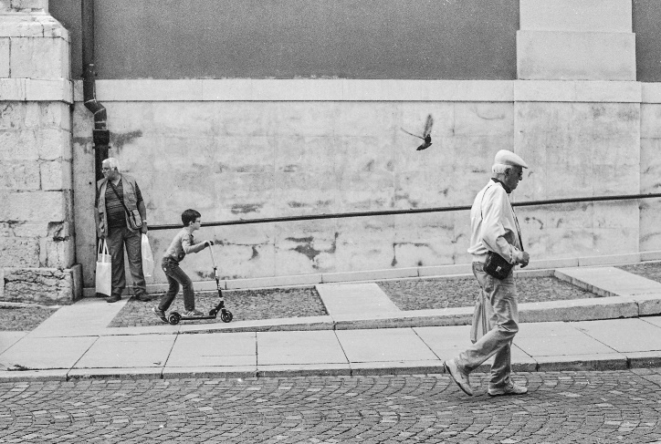
https://www.flickr.com/photos/europeanenvironmentagency/29234827051/in/album-72157673032944826/

