Influence of global megatrends on the state of environment in Slovenia
Introduction
In October 2017 the Slovenian Ministry of the Environment and Spatial Planning and the Environment Agency flor Slovenia commissioned Collingwood Environmental Planning (CEP) to support them in undertaking a study to understand the Influence of global megatrends on the state of environment in Slovenia.
Project objectives and scope
The main objective of this project is to adapt and apply the methodology described in the EIONET report ‘Mapping Europe's environmental future: understanding the impacts of global megatrends at the national level’ to analyse the potential implications of GMTs on the State of the environment in Slovenia and the ability of Slovenia to meet environmental goals set out in national strategic documents and the UN Sustainable Development Goals.
This project will consider global megatrends as analysed by the EEA in their European Environment State and Outlook Report (SOER) 2015. The EEA identified 11 global megatrends (GMTs) of relevant to Europe, and at the request of the Ministry of the Environment and Spatial Planning this project will focus on identifying potential implications of two specific GMTs: GMT 7: Intensified global competition for resources; and GMT 9: Increasingly severe consequences of climate change.
What are global megatrends?
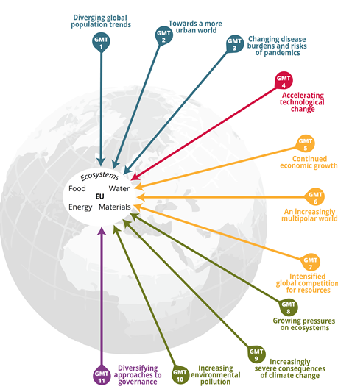
The EEA SOER 2015 defines global megatrends (GMTs) as ‘large-scale, high impact and often interdependent social, economic, political, environmental or technological changes’ that can have decisive and critical implications. The megatrends analysed in the EEA SOER 2015 provide a research- and expert-judgement-based perspective on how interrelated and connected global drivers and trends are likely to evolve over time. The EEA SOER 2015 assessment of GMTs analyses 11 megatrends that are considered to be of key importance to Europe’s long-term environmental outlook.

EEA’s Global Megatrends:
1. Diverging global population trends
2. Living in an urban world
3. Changing disease burden and risks of pandemics
4. Accelerating technological change;
5. Continued economic growth?
6. An increasingly multipolar world
7. Intensified global competition for resources
8. Growing pressures on ecosystems
9. Increasingly severe consequences of climate change
10. Increasing environmental pollution load
11. Diversifying approaches to governance.

Project tasks
Task 1: Preparatory work and project management
Key aspects of this task include clarifying the needs and expectations of the Ministry of the Environment identifying experts to be involved in the study; and setting out the project programme and outputs.
Task 2: Scoping implications
For this task the project team will collect and review background materials and prepare and facilitate a scoping workshop in Ljubljana (November 2017). Following the workshop a report on potential implications of GMTs 7 and 9 on the state of the environment in Slovenia will be prepared.
Task 3: Linking implications to national evidence
This task builds on the scoping outcomes and includes desk-based research and expert consultations to prepare summary factsheets on national information and outlooks related to identified GMT implications.
Task 4: Identifying risks, opportunities and responses
This task brings together results of Tasks 2 and 3 for discussion in an expert workshop (workshop 2) to identify and assess the risks and opportunities for the state of the environment in Slovenia from the GMT implications. The workshop will also provide an opportunity for experts to discuss policy gaps and potential responses to risks and opportunities. The aim is in particular to consider responses related to the ability of Slovenia to meet:
- The UN Sustainable Development Goals in Slovenia
- Goals set in the Slovenian national development strategy and national environmental strategy.
Task 5: Reporting
This task will bring together all project outcomes, and in particular the results of the two project workshops to prepare a final project report on impacts of GMTs 7 and 9 for the state of the environment in Slovenia and potential responses. Drawing in particular on Task 3, the final report will also include an overview of relevant indicators and outlooks identified through the project.

For more information please contact:
Barbara Bernard Vukadin, Project Manager (Slovenian Environment Agency)
barbara.bernard-vukadin@gov.si / 01 478 44 23
Owen White, Project Director (CEP)
o.white@cep.co.uk / +44 (0)117 315 5214
Rolands Sadauskis, Project Manager (CEP)
r.sadauskis@cep.co.uk / +44 (0)117 315 5214

https://www.eea.europa.eu/publications/mapping-europes-environmental-future-understanding
See: http://www.eea.europa.eu/soer#tab-global-megatrends

