**GMT 7: Intensified global competition for resources**

As they grow, economies tend to use more resources — both renewable biological resources (see GMT 8) and non‑renewable stocks of minerals, metals and fossil fuels. Industrial and technological developments, and changing consumption patterns associated with growing prosperity all contribute to this increase in demand. New technologies can create novel uses for resources and new ways to locate and exploit deposits, potentially increasing the burden on the environment. But innovations can also enable societies to reduce their use of finite and polluting resources and shift towards more sustainable alternatives.

The global use of material resources has increased 10-fold since 1900 and is set to double again by 2030, creating obvious risks. In addition to the environmental harm associated with resource extraction and exploitation, the world is a closed material system, and there are finite limits on the amounts of resources available. Even if resources are not scarce in absolute terms, they may be unevenly distributed globally, making access uncertain, increasing price volatility and potentially fostering conflict. Such concerns are particularly apparent with respect to a range of resources designated as 'critical raw materials'. For Europe, this is a major concern as its economy is structurally dependent on imports.

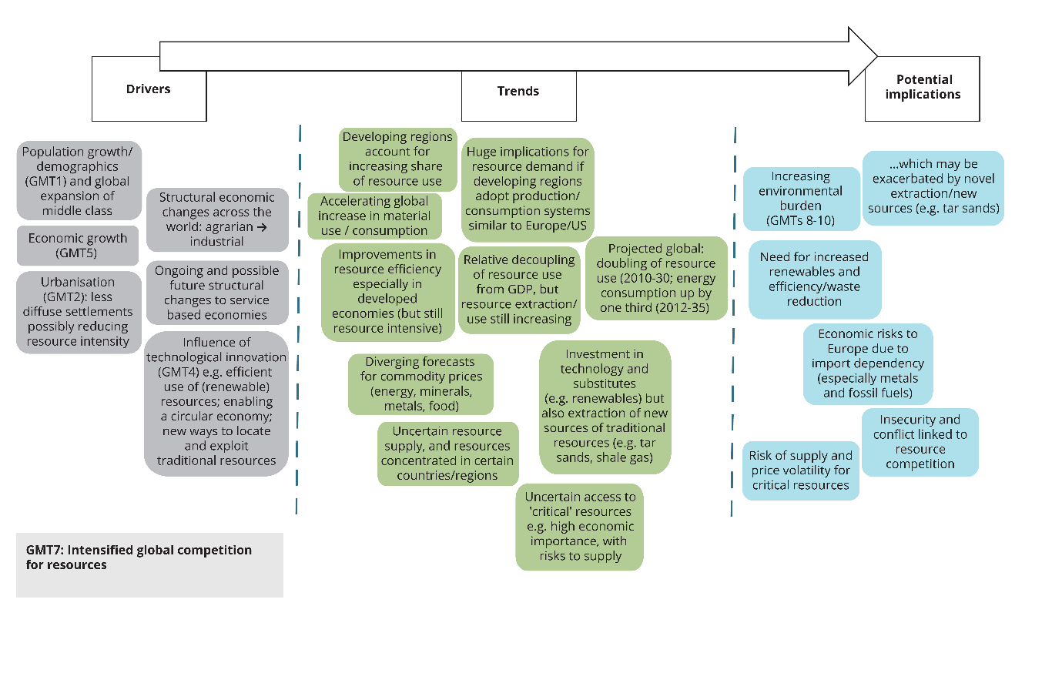

**GMT 9: Increasingly severe consequences of climate change**

In the past 150 years, the atmosphere and the oceans have warmed, snow and ice cover has decreased, sea levels have risen, and many extreme weather and climate events have become more frequent. This global warming and climate change are unprecedented over millennia.

The global mean temperature has increased by 0.85 °C since reliable measurements began in 1880 and is projected to increase further by the end of the 21st century — by between 1.0 °C, assuming strong emissions abatement, and 3.7 °C, assuming high emissions. This warming is expected to be accompanied by a global mean sea-level rise of up to 1 m, an increase of up to 2 °C in global upper-ocean temperature, a reduction of glaciers, ice sheets and sea ice, and an increase in the frequency of extreme weather events, such as droughts and floods, in many regions of the world.

Increasingly severe impacts of climate change are anticipated for the Earth's natural ecosystems, including substantial losses of biodiversity and increased rates of extinction. Of particular concern are ecosystems such as coral reefs, the Amazon forest and the boreal-tundra Arctic. Furthermore, climate change is likely to slow economic growth, erode global food security, increase global inequalities and adversely affect human health. These societal impacts are anticipated to be most severe in low-income countries and low-lying coastal areas.

Projected impacts directly affecting Europe include increased frequency of drought and water restrictions, increased damage as a result of flooding and increased impacts on human health from extreme temperatures.

