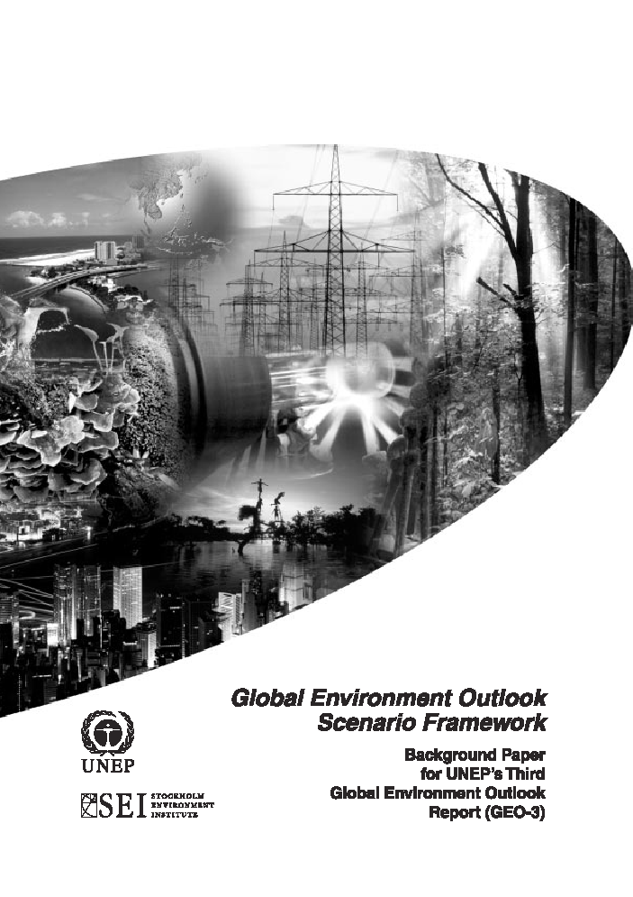

G L O B A L E N V I R O N M E N T O U T L O O K S C E N A R I O S

4 Scenario Narratives
Global and regional environmental outlooks are explored through four contrasting
visions of possible future global and regional developments. The scenarios are based
on the work of the Global Scenario Group (Gallopin and others, 1997; Raskin and
others, 1998 and Raskin and others, 2002), an organisation that was originally
established, in part, to provide a scenario framework for the GEO series. The
scenarios have been elaborated and given regional specificity through an
extended series of global and regional consultations.
The scenarios offer archetypal images of the future. All are plausible, none are
certain. In reality, as future events unfold, elements of all of the scenarios are likely to
be visible. Indeed, aspects of each of the scenarios can be seen in the world today.
The actual global development path over the next several decades could well include
features of each, along with unforeseen new elements. In the context of sustainable
development, a feature that distinguishes the scenarios is the different ways in which
the tension between economic growth and environmental limits is reconciled.
To review from the previous section, Market Forces envisages the global system
evolving without major surprises or sharp discontinuities as dominant values and
relationships shape a globally- integrated world. Economic development and
environmental preservation are addressed largely through market adaptations. In
a variation on this conventional story, Policy Reform pictures a world in which social
and environmental goals are actively pursued through comprehensive policies for
sustainable development, while still relying on the market to generate prosperity and
allocate resources. But there are other ways in which environmental limits on the scale
of economic activity might play out. Some visions are bleak, including the possibility of
authoritarian control over resources in order to avoid catastrophic environmental and
social breakdown – a Fortress World. Some are idealistic, picturing a fundamental
transition to a world dominated by post-consumerist values and lifestyles and high
levels of social equity – Great Transitions.

While the implications are complex, the essential stories that underlie each of the
scenarios may be captured in a sentence:
Market Forces: market-driven global development leads to convergence towards
dominant values and development patterns.
Policy Reform: incremental policy adjustments steer conventional development
towards environmental and poverty-reduction goals.
Fortress World: as socio-economic and environmental stresses mount, the world
descends toward fragmentation, extreme inequality and widespread conflict.
Great Transitions: a new development paradigm emerges in response to the
challenge of sustainability, distinguished by pluralism, planetary solidarity, and new
values and institutions. 15
The scenarios are summarised in Figure 2 with indicative sketches of their
behaviour over time for five six descriptive variables: population growth, economic
scale, environmental health, social and economic equity, technological change and
degree of social and geopolitical conflict. The environmental implications will be
elaborated in later sections. The curves are intended only as rough illustrations
of the possible patterns of change.

The Market Forces scenario refers to a future governed by a conventional
development paradigm of market-driven development, as represented by the
‘Washington Consensus.’ It features accelerated globalisation, trade liberalisation and
convergence of developing countries toward the development and institutional models
of industrialised countries. The dominant ‘western’ model of development prevails, as
consumerism and individualism spread as core values. It is believed that the most
effective poverty-reduction strategy is growth promotion, and that growth will tend to be
‘broad-based’ and will trickle down. Furthermore, economic growth is expected to
automatically repair the environmental damage caused by development. This scenario
is neither policy-free nor is it ‘business-as-usual.’ Rather, Market Forces is a normative
future that would require substantial policy initiatives at global, regional and national
levels to overcome the barriers to such a market-driven future, foster the necessary
institutional conditions and bring the developing world into the global market system.

Assumptions about Driving Forces

Demography gradual completion of demographic transition in most regions

Economy fairly stable growth rates

Society individual ethos dominates

Culture increasingly uniform; consumption-oriented

Technology rapid advances, but slightly outpaced by activity growth

Governance mix of top-down and bottom-up; reactive outside of economic arena; often rhetorical; degree of implementation varies; mixed results

Environment robust within limits

Like Market Forces, the Policy Reform scenario envisages the evolution of institutions
and values, the rapid growth of the world economy, and the convergence of global
regions toward the norms set by highly industrial countries. As in Market Forces,
western values still prevail. However, there is less faith that social and environmental
stresses can be mitigated adequately through the automatic responses of competitive
markets. The distinguishing feature of the Policy Reform scenario is the emergence of
the political will to constrain and guide market-driven growth with a comprehensive set
of sustainability policies. In Policy Reform, sustainability goals are pursued as a
proactive strategic priority. The goals are based on social and environmental targets
adopted by the international community and set at global, regional and national
levels. Comprehensive government action seeks to diffuse environmentally- friendly
technology, strengthen management systems and reduce poverty as encouraged by
the Earth Summit. Policy initiatives for achieving the goals are regionally differentiated
but include a mix of economic reform, regulatory instruments, voluntary actions, social
programmes and technology development. The Policy Reform vision is reflected in
much of the recent international discussion and negotiation on sustainable
development.

Assumptions about Driving Forces

Demography accelerated completion of demographic transition in most regions

Economy cautious growth balanced by social and environmental concerns

Society balance between individual and community ethos

Culture continues to be consumption-oriented, but tempered; respect for diversity

Technology targeted technological improvements; slightly outpaces activity growth

Governance top-down; proactive in intent; slow in implementation; mixed results

Environment robust within limits

The Fortress World scenario envisages the grim possibility that the social, economic
and moral underpinnings of civilization deteriorate, as emerging problems overwhelm
the coping capacity of both markets and policy reforms. The metaphor of the ‘fortress’
connotes a future of global polarisation, extreme inequity and rampant conflict, in which
increasing social and environmental stresses lead in time to increasingly authoritarian
‘solutions.’ The scenario has two faces: an elite minority in protected enclaves and an
impoverished majority eking out a precarious existence on the margin. Fortresses,
precursors of which can be seen in the world today, come in many varieties. They may
or may not involve a physical wall, and may be protected regions within a country or 16
may be a country to themselves. The fortresses are bubbles of privilege within
oceans of misery. Note that components of the environment may actually improve
under this scenario, as those in the fortresses reserve natural areas for their own
purposes. Furthermore, this scenario envisages a form of globalisation as the network
of fortresses coordinates economic exchange, security arrangements and global policy.
Meanwhile, the excluded majority has few options and few resources. This future need
not be unsustainable. It is plausible that such an unequal and authoritarian world might
be maintained for an indefinite time – but at what cost?

Assumptions about Driving Forces

Demography slow completion of demographic transition combined with stagnation or reversal of life expectancy among some groups

Economy laissez-faire approach to economic activity; increasingly disrupted

Society individual ethos dominates

Culture increasingly uniform within walls; fragmented and diverse outside

Technology fragmented technological advance; well behind growth in activity

Governance little at first; reactive; when applied, top-down and heavy handed

Environment a number of environmental systems exhibit increased fragility

The Great Transitions scenario offers a vision of a values-driven response to the
sustainability challenge. This global development alternative would be a fundamental
modification of the conventional development paradigm. The transitions emerge from
the growing consensus that the conventional ‘wisdom’ is both insufficient and
undesirable. As social and environmental sustainability becomes broadly accepted
as a basis for values, the conviction spreads that top-down policies alone are
inadequate to combat social inequities and ensure environmental resilience. Markets
are not abandoned as a policy tool but social, cultural and environmental goals take
priority. Material flows through the economy are moderated as population growth in
developing regions and consumerism in richer regions abate. Eco-efficient production
processes and green technologies are deployed everywhere. Among the affluent,
disillusionment with consumerism prompts a search for more fulfilling ways of living,
while in the less-affluent regions a new generation of thinkers, leaders and activists
shape a ‘new development paradigm’. The period is characterised by a cultural
renaissance, based on respect for life, the social community, equity within and
between generations, and social solidarity. Wealth and access to resources are
much more equitably distributed than today or in the other scenarios.
In some ways, Policy Reform and Great Transitions scenarios are similar. Each
seeks to meet sustainable development goals. The difference between them is in
the underlying values that determine human action. The effect of this difference on
economic and material development is illustrated in Figure 3 (Robinson and Tinker,
1996; Raskinand others, 2002). The assumptions that underlie the two scenarios are
compared to those that underlie the Market Force scenario, in which well-being is
identified with consumption. Material throughput, in turn, is tightly tied to the economy.
Policy attention is not focused on questions of distribution, and the incomes of rich and
poor diverge in absolute terms, although there is some convergence in relative terms.
The Policy Reform story breaks with this pattern by separating consumption and
material throughput through technological means, illustrated in the figure by the
‘dematerialisation wedge.’ Policy attention focuses on poverty reduction, which
tends to reduce inequities. The decline in inequality between countries is dramatic
when compared to past patterns but, despite the changes, strong inequalities still
characterise the world in 2032. The Great Transitions scenario introduces further
changes. In this story, concepts of well-being are separated from consumption,
illustrated in Figure 3 by the ‘lifestyles wedge.’ The dematerialisation wedge is still
active, leading to the possibility of considerable reductions in material throughput. In
this scenario, attention goes beyond poverty reduction to emphasise greater equity.
This is represented in the figure by the ‘equity clamp,’ which rapidly narrows the gap
between rich and poor.

Assumptions about Driving Forces

Demography greatly accelerated completion of demographic transition in most regions

Economy new patterns of economic activity; old measures inadequate to represent changes

Society community ethos dominates, but with full flowering of individual potential

Culture shift from consumption to satificing-orientation; respect for diversity

Technology targeted technological advances; well ahead of activity changes

Governance bottom-up dominates; proactive in intent and implementation; strong results

Environment robust within limits

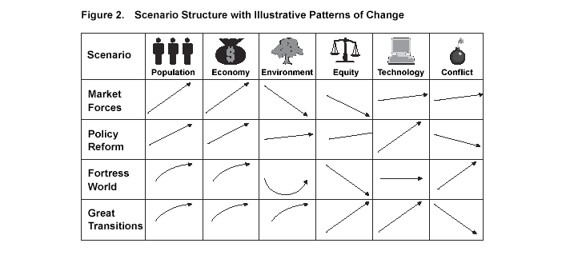

GEO 3 Driving forces

There are many socio-economic factors driving environmental change. How these factors evolve will shape global and regional development and the state of the environment far into the future.
Trends may continue as they have in the past or change speed and direction — perhaps even going into reverse. Trends may lead to convergence or divergence between circumstances in different regions of the world. Trends in one region or responses to one driving force, may oppose others that originate elsewhere, or they may run up against absolute physical limits.
The scenarios explored in the pages that follow are based on certain assumptions about how these driving forces will evolve and interact with developing situations, potential future shocks and human choices. This section briefly describes the assumptions made about driving forces underlying the scenarios and, in particular, how these assumptions differ from scenario to scenario.

The seven driving forces under consideration are demography, economic development, human development, science and technology, governance, culture and environment. The environment is included as a driving force because it is more than a passive receptacle for change. Just as the assumptions about human and societal behaviour shape the scenarios, so do the assumptions about pressures exerted by the environment. Developments arising from each of the driving forces will not unfold in isolation from one another. Issues will interweave and chains of cause and effect are likely to be hard to trace back to individual sources. Finally, any number of possible future trends could be constructed from the available array of variables. Narrowing down this range to a small, yet richly, contrasting set of futures that is consistent, plausible, recognizable and challenging, will depend on the extent to which one starts outwith an intelligent set of assumptions.

Demography
Population size, rate of change, distribution, age structure and migration are all critical aspects of demography. Population size governs to a great extent demand for natural resources and material flows. Population growth increases the challenge of improving living standards and providing essential social services, including housing, transport, sanitation, health, education, jobs and security. It can also make it harder to deal with poverty. Rapid population growth can lead to political and social conflict between ethnic, religious, social and language groups. Increases in the number of people living in towns and cities are particularly important because urbanization means large changes in lifestyle, consumption patterns, infrastructure development and waste flows. Population structure — the relative proportion of
children, persons of working age and elderly people within a population — has important repercussions for future population growth as well as for matching the provision of education, healthcare, incomes and pensions to predicted needs. Finally, internal and international migration, whether voluntary or forced, can sometimes ease and sometimes worsen the pressures that other demographic factors and other forces place on society and the environment.
Because so many of the people who will have children over the next 30 years have already been born, much can already be said about population over that period. All of the scenarios assume continued growth in global population, tailing off at the end of the period, as more countries pass through the demographic transition. Nearly all the growth occurs in developing countries, with North America as the only developed region with noticeable growth.

Slightly lower population levels are foreseen in Policy First and Sustainability First, reflecting the idea that policy actions and behavioural changes speed up the transition to slower growth. In Security First, lack of effective policy, and much slower economic and social development, combine to slow down the transition. This leads to significantly higher population levels in this outlook, regardless of devastating demographic trends or events such as the HIV/AIDS pandemic in Africa that might be expected to have the contrary effect.

Urbanization increases or remains stable in almost all regions in all the scenarios, with the greatest increase in those regions currently least urbanized — Africa and much of Asia and the Pacific. In all regions, much of the development occurs in large coastal cities, a shift with serious implications for the coastal environment. Apart from the Antarctic sub-region, which has no permanent resident population, current and future population structure differs markedly from region to region. North America, Europe and Japan have significantly larger shares of elderly people, a pattern that persists and increases in all scenarios. This trend is less marked in Security First, where advances in medical science (and hence in life expectancy) make less headway in all regions. Other areas, particularly Africa, West Asia, Latin America, and the Caribbean and South Asia, are dominated by youth. Their share of the population in these regions — but not their absolute population size — gradually decreases over the next 30 years in all scenarios.

In terms of migration patterns, Markets First and especially Security First are likely to have more conflicts and inequality, provoking more and more movements of refugees and economic migrants. Whereas more openness is assumed under Markets First, barriers to migration are expected in Security First. Policy First and Sustainability First also assume more open migration, especially for refugees and displaced communities. At the same time, more equitable sharing of resources for economic development and international assistance reduce the need for migration.

Economic development
Economic development encompasses many factors, including production, finance and the distribution of resources, both between regions and across sectors of society. Although the pattern varies conspicuously, there has been a general trend towards more service-based economies.
Product, financial and even labour markets are becoming increasingly integrated and interconnected in a worldwide economy with global commodity chains and financial markets. Similar trends are appearing at regional level in several parts of the globe. These trends have been spurred on by advances in information technology, international pacts designed to remove trade barriers or liberalize investment flows and the progressive de-regulation of national economies. The same advances have also allowed wealth produced by national and transnational mergers to become concentrated in fewer and fewer hands. There has also been an increase in inequality in terms of income and resource use across — and often within — nations. For many nations the problem of inequality is made worse by debt burdens that seriously constrain growth. As transnational enterprises respond to global business opportunities, the traditional prerogatives of the nation-state and the capacity for macro-economic intervention by the state are challenged anew.

In Markets First, most of the trends noted above are assumed to persist, if not accelerate. Economic development outweighs social and environmental concerns in most international discussions. Resistance continues, but no radical changes in policy result. Recognition that maintenance of environmental and social conditions is important for ensuring economic development slows economic growth down over time, but not very noticeably. In Security First, trends towards global integration continue for some parts of the economy, yet come to a halt or even go into reverse for others. Over time, more and more activity takes place in the grey or underground economy. Integration trends persist in Policy First and Sustainability First but are tempered by the introduction of new policies and institutions to tackle social and environmental concerns. This reflects improved understanding of the crucial roles of human, social and natural capital in determining economic health. Changes in attitudes and behaviour in Sustainability First affect these trends more than in the other scenarios as the whole notion of economic development becomes increasingly subsumed in the broader concept of human development. The effect of these changes on per capita income shows a strong variation across regions and
scenarios. Average income growth in all regions is lowest in Security First, but is also very unevenly distributed due to the greater inequality within regions. In the other scenarios, average growth at the global level is similar but there are key differences between and within regions. In Policy First, the more equitable distribution of growth allows average incomes of the wealthy to grow slightly slower than in Markets First, whereas incomes rise more rapidly among the poor. The most dramatic increases in income growth are seen in Africa, but also in parts of Latin America and the Caribbean, Asia and the Pacific, and West Asia. The convergence in per capita incomes is even greater in Sustainability First, especially as wealthier persons shift their emphasis away from market-oriented production and consumption. However, large differences remain at the end of the 30-year period.

Human development
Health, education, security, identity and freedom are aspects of human development that are all clearly related to economic development, yet go well beyond it. Dramatic differences in access to these important human needs comprise a feature of the contemporary global scene. Impoverishment and inequity are critical problems for the poorer countries but conspicuous pockets exist, even in the richest countries. As the world grows more interconnected, these forces affect everyone directly or indirectly, through immigration pressure, geopolitical instability, environmental degradation and constraints on global economic opportunity. The United Nations, World Bank, International Labour Organization (ILO) and International Monetary Fund (IMF) recently set out specific international development goals for poverty reduction, universal primary education, gender equality, infant and child mortality, maternal mortality, reproductive health and the environment. Achieving these goals depends on: ‘Stronger voices for the poor, economic stability and growth that favours the poor, basic social services for all, open markets for trade and technology, and enough development resources, used well’ (IMF and others, 2000).

Among obstacles to achieving these goals are ‘weak governance, bad policies, human rights abuses, conflicts, natural disasters and other external shocks. The spread of HIV/AIDS, the failure to address inequities in income, education and access to health care, and the inequalities between men and women. But there is more. Limits on developing country access to global markets, the burden of debt, the decline in development aid and sometimes inconsistencies in donor policies also hinder faster progress’ (IMF and others, 2000). Policy First and Sustainability First place emphasis on meeting basic needs and providing the resources to meet them, even where this may hinder short-term economic growth. In Sustainability
First, relatively more basic needs’ provision comes from groups outside the public sector, both businesses and non-governmental organizations.
In Markets First, these issues are not addressed to the same extent, as it is taken for granted that economic development naturally leads to social improvement. In addition, more of the facilities that have traditionally been provided as public services are privatized. These trends are even more pronounced in Security First, accompanied by greater inequality in terms of access. Where new funds, whether public or private, are invested in development, physical security increasingly takes
precedence over social welfare.

Science and technology
Science and technology continue to transform the structure of production, the nature of work and the use of leisure time. Continuing advances in computer and information technology are at the forefront of the current wave of hi-tech innovation. Biotechnology galvanizes agricultural practices, pharmaceutical development and disease prevention, though it raises a host of ethical and environmental issues. Advances in miniaturized technologies transform medical practices, materials science, computer performance and much more. The importance of science and technology extends beyond the acquisition of knowledge and how it is used. Continuing concerns over the distribution of the benefits and costs of technological development provoke much national and international debate. Such concerns include technology transfer, intellectual property rights, appropriate technologies, trade-offs between privacy and security, and the potential for information-poor countries to find themselves on the wrong side of a ‘digital divide’. The ultimate resolution of these matters influences the future development of science and technology, as well as their impacts on society and the environment. In Markets First, it is assumed that the rapid technological advances of recent years continue, but are increasingly driven by profit motives. Over time this may actually slow down development as basic research is given less priority. Technology transfer, intellectual property rights and other issues are tackled, but mainly to the advantage of those with greater power in the marketplace.

Environmental benefits largely come about as side-effects of efforts to improve the efficiency of resource use. These patterns are even more pronounced in Security First, where — in addition — the diversion of more and more public funding into security provision, coupled with social, economic and environmental crises, means slower progress all round. Rapid advances in science and technology are also assumed in the Policy First and Sustainability First scenarios, but these are driven by different factors. Direct investment by governments, subsidies and regulation — for example, pollution taxes — play a dominant role in Policy First. In Sustainability First, these levers are overshadowed by changing preferences of both consumers and producers. In both scenarios, greater caution on the part of governments and society at large may slow down technological development in some areas but also helps to head off serious side-effects. Greater efforts are also made to share the benefits of science and technology.

Governance
Governance refers to actions, processes, traditions and institutions by which authority is exercised. It is most often associated with governmental bodies at the national level and with regional or global institutions such as the United Nations, but this need not always be the case. Private institutions, such as corporations and non-governmental organizations, also play an important role in governance. In all cases, developments that affect participation, accountability, transparency,
corruption and civil strife have an important influence on the shape of the future.
Although the forms and effectiveness of governance differ markedly around the world, various tendencies can be identified. One tendency is towards greater individual autonomy and the devolution of authority. This shift is expressed at the personal level in terms of a growing emphasis on individual rights, especially women’s rights. It is also noticeable in the devolution of governmental authority to smaller and more local units, and in separatist movements. The private sector, too, has moved towards ‘flatter’ corporate structures and decentralized decision-making. A second and somewhat opposite tendency is towards forms of greater regional integration and global governance through such mechanisms as international trade and environmental agreements. Another tendency is towards greater integration and the growth of networks within and across private and public institutions. This is seen, in part, in the rise of global public policy networks and the emergence of civil society as an important voice in decision-making in many regions.

In Markets First, present trends are assumed to continue but with heavier emphasis on ensuring the smooth functioning of markets. Efforts are focused on the development of international institutions that will encourage free markets for resources, finance and products. In Policy First, greater coordination is assumed, particularly at the level of international governance. This includes the development of new institutions and more cooperation between the public and private sectors. Significantly, these changes are driven from the top by governments, corporations or large nongovernmental organizations (NGOs).

In Sustainability First, the shifts in governance are assumed to be driven much more from the bottom up. Reflecting the changing values and making use of the trends towards greater participation, in general, individuals and grassroots organizations become more and more involved in setting the agenda, a lead that larger organizations then follow. Governments continue to govern but do so in a fashion that involves more power sharing.

As with other aspects in the Security First scenario, assumed trends regarding governance differ over time and across groups more than in the other scenarios. Corruption, ineffective governance and reactions against both contribute to breakdown in parts of society. As societies regroup, governance among the ‘haves’ is assumed to become more centralized and autocratic, but largely effective. International coordination also bolsters the relative stability of these groups. The nature and effectiveness of governance is mixed among the ‘have-nots’.

Culture
Culture includes the set of values and institutions that enables a society to develop and maintain its identity. Cultural signatures differ around the globe and reflect, for instance, conflicting ideas about the worth of economics as an integrating system of values or about the importance of technology and technological change as springboards for human progress. Cultural signatures also hinge on differing concepts of justice and fairness, and on differing beliefs about the relationship between people and the natural and spiritual world.

Recent history, particularly where racism, colonialism and genocide have been present, cannot be overlooked. Much has been said about the expansion of Western culture to the detriment of other cultures, about reactions to this spread and about possible clashes of civilizations as a result. To some, it is clear that many individuals aspire to Western lifestyles, while others see Western values permeating societies and associate them with selfish individualism and excessive consumption. This spread represents both a cause and an effect of economic globalization, aided by the far-reaching penetration of information technologies and electronic media. At the same time, there have been clear signs of nationalist and religious reaction against it, sometimes resulting in terrorist activities and in open warfare within or between nations. Among the four scenarios, Sustainability First assumes the largest shift from current trends in terms of culture. The ascendancy of the values of solidarity, reciprocity, sufficiency and stewardship is at the heart of this scenario. To the extent that these core values are not violated, tolerance is also a key aspect of culture in this scenario.

In Markets First, little change in current trends is assumed. As befits the basic notion of a market, the trend towards individualism accelerates, as does a trend towards homogenization of culture. At the same time, so does passive and active resistance by particular groups and regions. In Security First, these and other trends lead to clashes that undermine many elements of society. Policy First assumes a middle path between Markets First and Sustainability First; efforts to encourage some of the trends of the latter compete with tendencies to follow the trends of the former.

Environment
Though the focus of this section is on the importance of socio-economic change in triggering environmental impacts, it is clear that environmental change is a potent driving force in its own right. Countries and regions must contend not only with unequal environmental endowments, but also with acute environmental problems. Human impacts on the environment have aroused growing anxiety. Atmosphere, land and water resources have been spoiled. Persistent organic pollutants and toxic substances have accumulated in living organisms. Species have been lost and ecosystems degraded. In addition, social and ecological systems are vulnerable to natural and human-influenced hazards and catastrophes.

The way natural systems react to these pressures (the rate, for instance, at which climate patterns change as a result of higher concentrations of greenhouse gases, or the response of coastal ecosystems to pollution) can have a large impact on social, economic and other natural systems. The realization that individual states cannot shield themselves from environmental change is already changing the basis of geopolitics and global governance. The scenarios presented here do not differ greatly in their assumptions about the environment as a driving force. Most significantly, it is assumed that natural systems are in a more fragile condition
in Security First than in the other scenarios. This implies that ecosystem collapses and curbs on the capacity of certain natural systems to provide goods and services are more likely, even when facing the same pressures. In Policy First and especially in Sustainability First, the values of stewardship and caring for the environment play a greater role in guiding science, technology and governance, as well as in shaping economic and social development.

